
INDUSTRY REPORT
Management Consulting in the US
Mar 2026

About

IBISWorld
IBISWorld specializes in industry research with coverage on thousands of global industries. Our comprehensive data and in-depth analysis help businesses of all types gain quick and actionable insights on industries around the world. Busy professionals can spend less time researching and preparing for meetings, and more time focused on making strategic business decisions.

Table Of Contents | Standard

1. About 4
Codes 4
Definition 4
Related Terms 4
What's Included 5
Companies 5
Related Industries 5
Additional Resources 6
2. At a Glance 7
Key Takeaways 7
Products and Services 8
Major Players 9
Key External Drivers 10
Industry Structure 10
SWOT 11
Executive Summary 11
3. Performance 13
Highlights 13
Key Takeaways 13
Performance Snapshot 14
Outlook 23
Life Cycle 26
4. Products and Markets 27
Key Takeaways 27
Products and Services 27
Major Markets 33
International Trade 36
5. Geographic Breakdown 37
Key Takeaways 37
Business Locations 38
6. Competitive Forces 46
Key Takeaways 46
Concentration 46
Barriers to Entry 48
Substitutes 49
Buyer & Supplier Power 50
7. Companies 52
Key Takeaways 52
Market Share 53
Companies 54
8. External Environment 63
Key Takeaways 63
External Drivers 63
Regulation & Policy 66
Assistance 67
9. Financial Benchmarks 68
Key Takeaways 68
Cost Structure 68
Financial Ratios 72
Valuation Multiples 78
Key Ratios 79
10. Key Statistics 81
Industry Data 81

1. About
https://my.ibisworld.com/us/en/industry/54161/about

Codes
NAICS 2017 - USA | 54161
NAICS 2017 - USA | 541611
NAICS 2017 - USA | 541613
NAICS 2017 - USA | 541614
NAICS 2017 - USA | 541618
NAICS 2022 - USA | 54161
NAICS 2022 - USA | 541611
NAICS 2022 - USA | 541613
NAICS 2022 - USA | 541614
NAICS 2022 - USA | 541618

Definition
Operators in the industry advise businesses, nonprofits and public-sector agencies in areas such as organizational planning design, human resources policies, practices and planning, corporate strategy, information technology strategy, marketing and sales, financial planning and budgeting and logistics.

Related Terms

MANAGEMENT CONSULTANT
A consultant who provides advice and assistance to businesses and other organizations on various issues, including management.

STRATEGIC CONSULTING
The contracting of a consultant to advise on long-term planning with an eye toward minimizing costs and maintaining profit, often in conjunction with the development of new products and services.

HUMAN RESOURCES CONSULTING
The contracting of a consultant for advice on structuring human resource and personnel policies, employee benefits, compensation systems and wage and salary administration.

DEFINED BENEFIT PENSION PLAN
A retirement pension plan in which an employer commits to paying its employee a specific benefit for life beginning at his or her retirement.

DEFINED CONTRIBUTION PENSION PLAN
A retirement pension plan in which an employer's annual contribution is specified. The value of future benefits at the time of retirement is not specified.

What's Included
- Strategic management consulting, and consulting combined with implementation
- Financial management consulting, and consulting combined with implementation
- Marketing management consulting, and consulting combined with implementation
- Human resources management consulting, and consulting combined with implementation
- Operations and supply chain management consulting, and consulting combined with implementation
- Actuarial consulting (except for employee pensions and other benefits)
- IT technical design, consulting, and development services
- Organizational development

Companies
- Deloitte Touche Tohmatsu
- Accenture Plc
- Pricewaterhousecoopers Llp

Related Industries

Industries in the Same Sector
- Competitors:
  - Accounting Services in the US
  - IT Consulting in the US
  - Human Resources Consulting in the US
  - Environmental Consulting in the US
- Complementors:
  - Tax Preparation Services in the US
  - Business Coaching in the US

International Industries
- Global Management Consulting
- Management Consulting in Canada
- Management Consulting in Australia
- Consulting Services in New Zealand
- Management Consulting in the UK
- Occupational Health & Safety Services in the UK
- Procurement Outsourcing Services in the UK
- Management Consulting in Germany
- Management Consulting in Ireland
- Management Consulting in China

Additional Resources
- Consultant-News.com
- Consulting Magazine
- Institute of Management Consultants USA
- US Census Bureau

2. At a Glance
https://my.ibisworld.com/us/en/industry/54161/at-a-glance
Revenue  $411.7bn  ’21-’26 ↑ 2.1 %  ’26-’31 ↑ 1.0 % | Employees  2m  ’21-’26 ↑ 4.5 %  ’26-’31 ↑ 1.9 % | Businesses  1m  ’21-’26 ↑ 4.1 %  ’26-’31 ↑ 2.9 %
Profit  $45.3bn  ’21-’26 ↑ 0.5 % | Profit Margin  11.0%  ’21-’26 ↓ 0.9 pp | Wages  $206.4bn  ’21-’26 ↑ 3.6 %  ’26-’31 ↑ 1.7 %

Key Takeaways

Performance
- Product and market variety continue to generate consistent consultant performance. Serving diverse downstream clients, such as financial and industrial companies and offering services ranging from technical to strategic support, ensures revenue growth for management consultants, even during economic fluctuations.
- The technology tide heightens the need for skilled workers. The greater proliferation of automated technology and expansion of digital business solutions will drive higher competition among technically skilled consultants.

Products and Markets
- Providing corporate strategy services remains a popular and wide-ranging service. These services see the greatest demand among consulting offerings and are a key driver of client growth irrespective of their sector or business.
- Client diversification opens niche opportunities. Serving a diverse client base, from private financial companies to public government organizations, allows consultants to specialize in niche consulting offerings and creates consistent revenue streams.

Products and Services
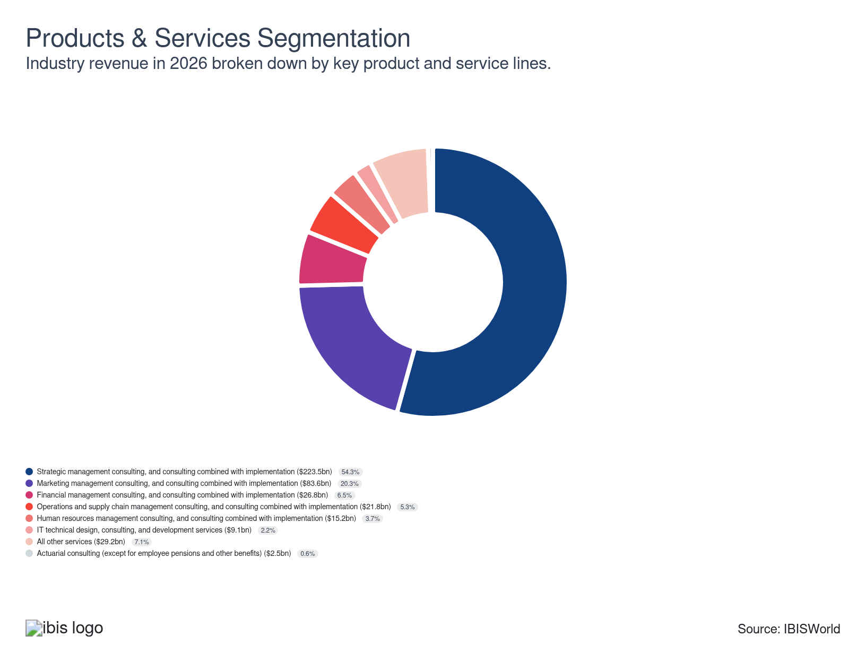

Major Players
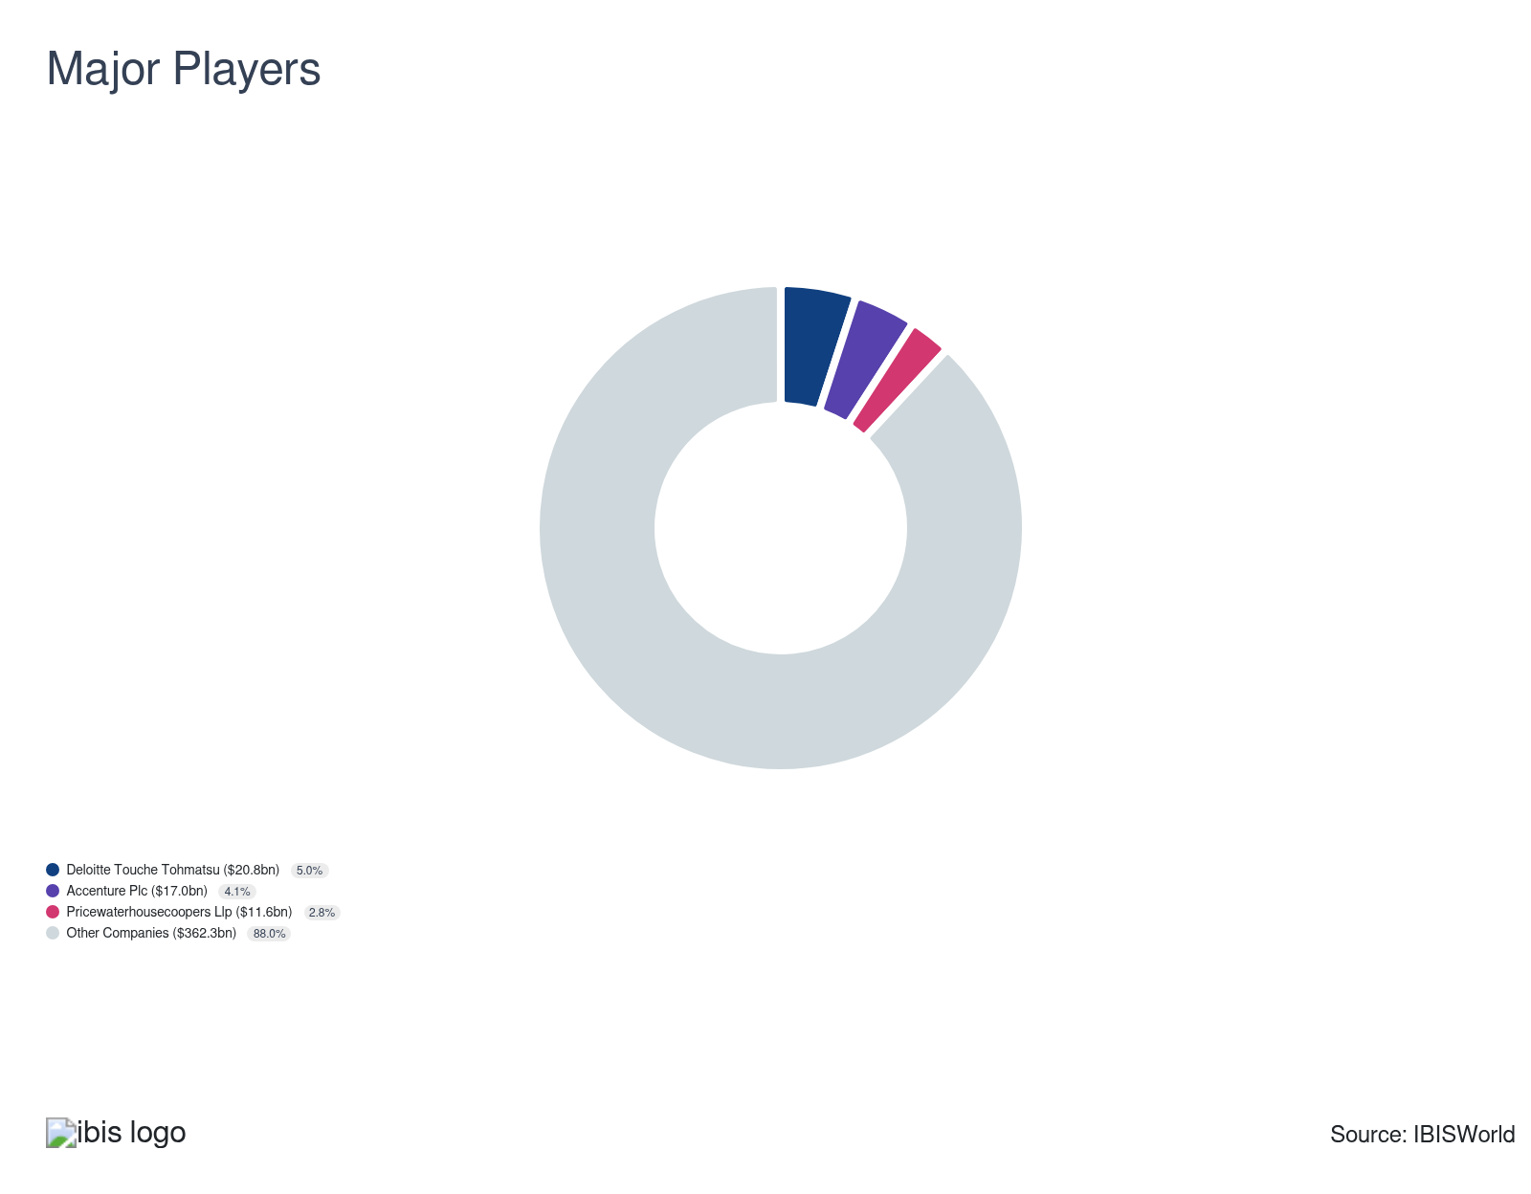

Key External Drivers
Key External Drivers | Impact
Number of businesses | Positive
Government consumption and investment | Positive
Aggregate private investment | Positive
Business sentiment index | Negative
Corporate profit | Negative

Industry Structure
Characteristic | Level | Trend
Concentration | Low
Barriers To Entry | Low | Steady
Regulation and Policy | Low | Steady
Life Cycle | Mature
Revenue Volatility | Low
Assistance | Moderate | Steady
Competition | High | Increasing
Innovation | Moderate

SWOT
Strengths  Low Volatility  Low Imports  Low Customer Class Concentration  Low Capital Requirements | Weaknesses  Low & Steady Barriers to Entry  High Competition  Low Profit vs. Sector Average  High Product/Service Concentration  Low Revenue per Employee | Opportunities  High Revenue Growth (2021-2026)  High Performance Drivers  Number of businesses | Threats  Low Revenue Growth (2005-2026)  Low Outlier Growth  Low Revenue Growth (2026-2031)  Corporate profit

Executive Summary

Logistical concern: Anticipated growth in business sentiment and aggregate private investment will boost demand for seasoned consultants
Management consultants continue to benefit from strategic planning and marketing services demand across commercial and individual markets. Providing varied services to diverse downstream markets with unique needs allows management consultants to weather changing economic conditions. Core business interests, such as strategic planning, came into extra demand when inflationary spikes in 2022, interest rate increases in 2023 and new tariff implementation in 2025 accelerated business costs. Major consultancy firms such as Deloitte and Accenture PLC pivoted to business strategy and financial management consultation services due to businesses’ desire to secure capital and hedge against an increasingly uncertain tariff landscape when pursuing a new investment or acquisition. However, while economic turbulence curtailed consultants’ growth rate, high service diversification and new technology adoption, such as artificial intelligence (AI), reduced manual labor dependence and strengthened service quality across competitive sectors such as finance. Revenue grew at a CAGR of 2.1% to an estimated $411.7 billion over the past five years, including an estimated 0.9% boost in 2026 alone.
Technological change in client markets drove spending on tech-centered consulting services, such as IT design and strategic planning. Companies aiming to advance sustainability initiatives like Environmental, Social and Governance (ESG) standards embrace digital transformation and leverage big data analytics expand the need for expert consultants. The ability to hire remote workers broadens the labor pool's quality and scope, but also lessens consultants' negotiating power as other companies can now access previously restricted markets and recruit top talent. Consulting firms are no longer tethered to densely populated areas, allowing relocation to cities with lower rent and labor costs. While technology offers cost savings and expanded markets, it also intensifies competition for labor and clients, curtailing profitability.
Moving forward, management consultants are poised to take advantage of favorable economic conditions and a larger digital market that will change how marketing is conducted. While there are low barriers to entry in consulting, with the top 20 firms representing almost one-quarter of firm revenue, small-sized entrants face stiff competition. As consolidation continues, the entry of niche firms specializing in new technology (IT, VR, AR and AI) is expected to increase, as these companies can better compete with larger consulting firms. The acceleration of social media and digital advertising will provide lucrative opportunities for specialized marketing management consultants, particularly as 53.0% of consumers procure information via social media platforms per 2025 data from the Pew Research Center. Revenue is poised to grow at a CAGR of 1.0% to an estimated $432.4 billion over the next five years.

3. Performance
https://my.ibisworld.com/us/en/industry/54161/performance

Highlights
Revenue  $411.7bn  2021-26 CAGR ↑ 2.1 %  2026-31 CAGR ↑ 1.0 % | Employees  2m  2021-26 CAGR ↑ 4.5 %  2026-31 CAGR ↑ 1.9 % | Businesses  1m  2021-26 CAGR ↑ 4.1 %  2026-31 CAGR ↑ 2.9 %
Profit  $45.3bn  2021-26 CAGR ↑ 0.5 % | Profit Margin  11.0%  2021-26 CAGR ↓ 0.9 pp

Key Takeaways
- Product and market variety continue to generate consistent consultant performance. Serving diverse downstream clients, such as financial and industrial companies and offering services ranging from technical to strategic support, ensures revenue growth for management consultants, even during economic fluctuations.
- The technology tide heightens the need for skilled workers. The greater proliferation of automated technology and expansion of digital business solutions will drive higher competition among technically skilled consultants.

Performance Snapshot
Revenue: | ↑ 2021-26 Revenue CAGR +2.1%
Revenue  $411.7bn  ’21-’26 ↑ 2.1 %  ’26-’31 ↑ 1.0 % | 2026 Revenue Growth  ↑ 0.9 % | Revenue Volatility  Low
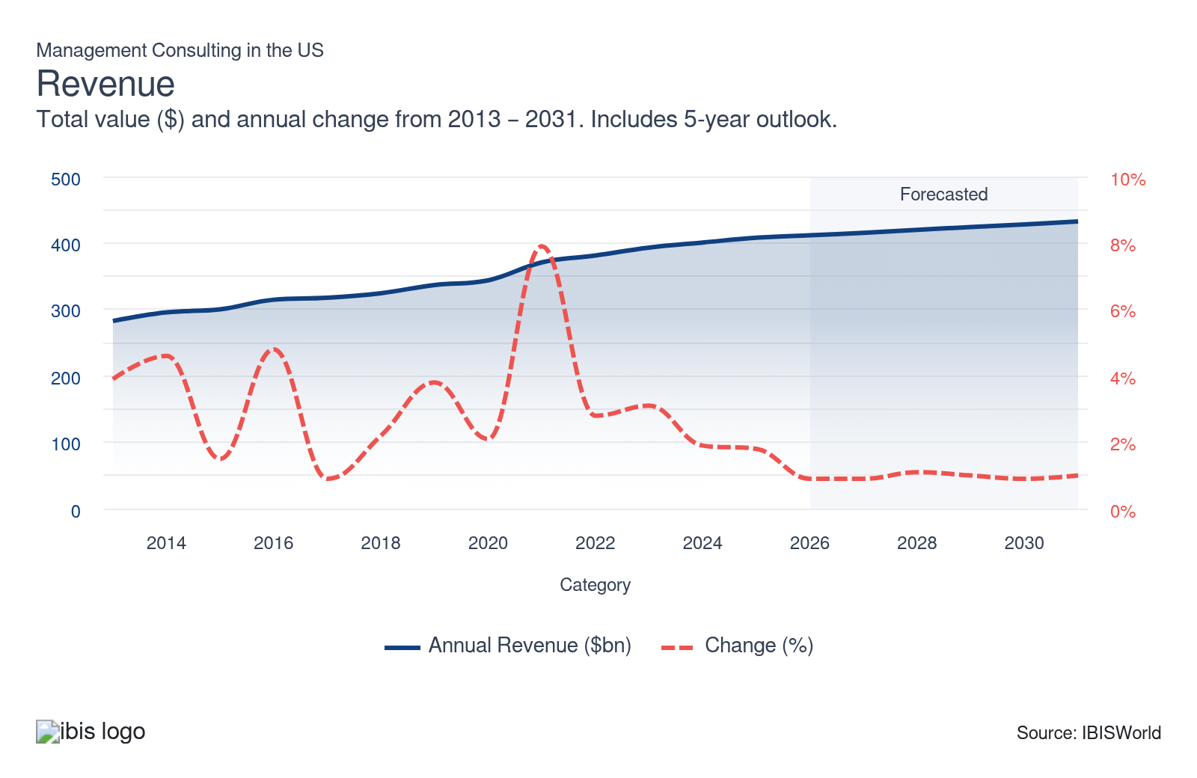
Employees: | ↑ 2021-26 Employees CAGR +4.5%
Employees  2m  ’21-’26 ↑ 4.5 %  ’26-’31 ↑ 1.9 % | Employees per Business  2  ’21-’26 ↑ 0.3 %  ’26-’31 ↓ 1.0 % | Revenue per Employee  $167k  ’21-’26 ↓ 2.2 %  ’26-’31 ↓ 0.9 %
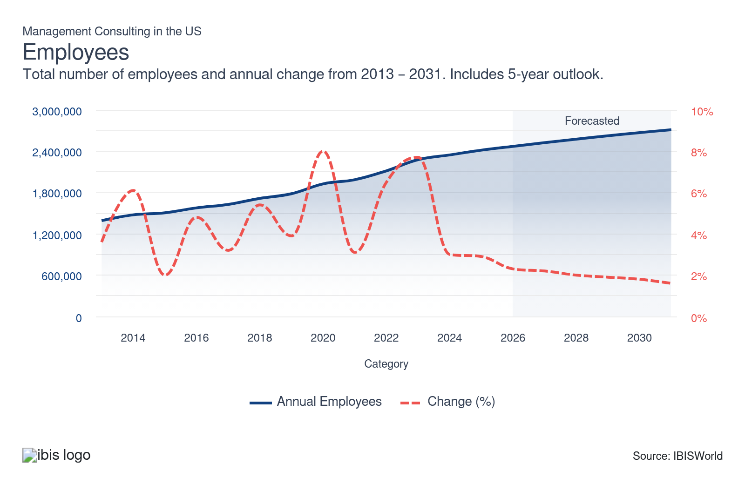
Businesses: | ↑ 2021-26 Business CAGR +4.1%
Businesses  1m  ’21-’26 ↑ 4.1 %  ’26-’31 ↑ 2.9 % | Employees per Business  2  ’21-’26 ↑ 0.3 %  ’26-’31 ↓ 1.0 % | Revenue per Business  $371.2k  ’21-’26 ↓ 1.9 %  ’26-’31 ↓ 1.9 %
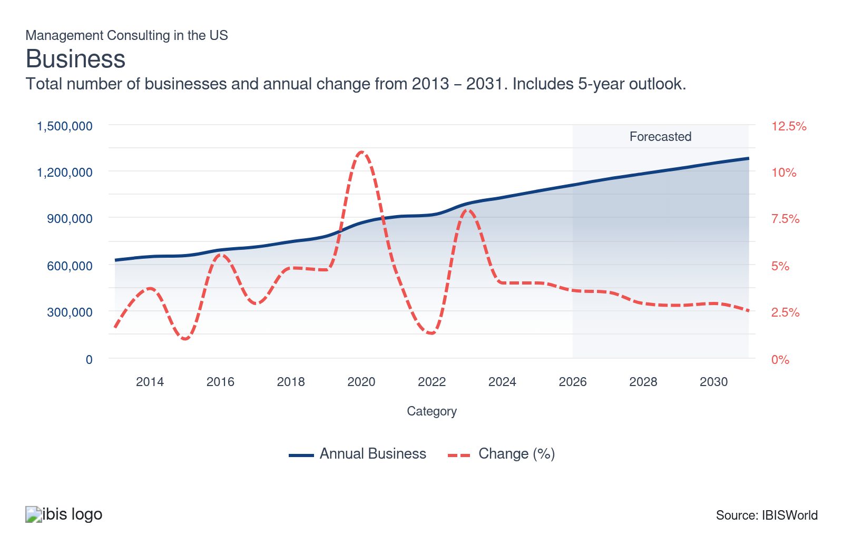
Profit: | ↑ 2021-26 Profit CAGR +0.5%
Total Profit  $45.3bn  ’21-’26 ↑ 0.5 % | Profit Margin  11.0%  ’21-’26 ↓ 0.9 pp | Profit per Business  $40,827
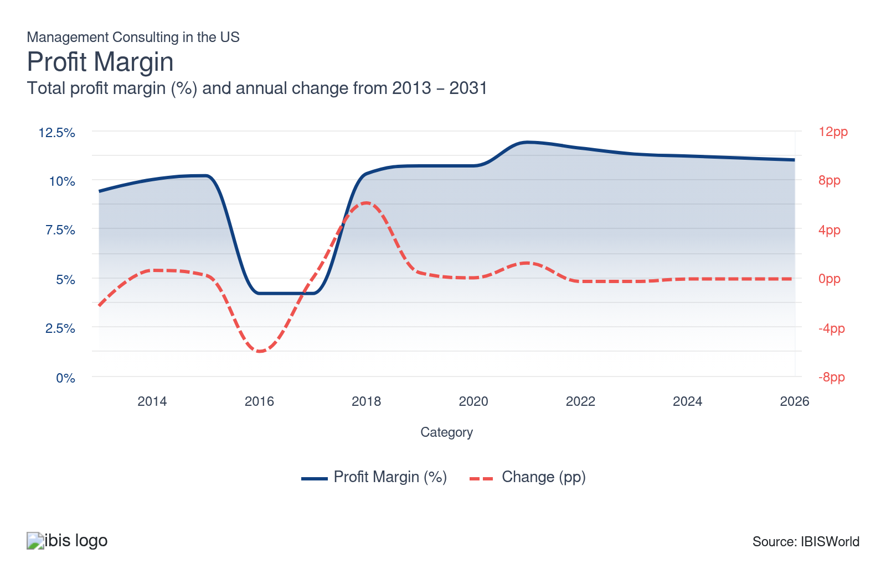
Current Performance
Current Performance

What's driving current industry performance?

Diverse service provision for various downstream clients creates a steady market for consultants
- A core factor that generated steady demand for management consultants is the wide range of client service offerings. Diverse service offerings to a range of downstream clients, such as businesses, governments, nonprofit organizations and individuals, insulated consultants from volatility, as these clients respond in varying degrees to macroeconomic conditions. Because of the market uncertainty fueled by inflation spikes in 2022, elevated interest rates and new tariffs, clients looked to procure qualified consultants who could assist in crafting short- and long-term business strategies.
- By providing different services like organizational planning, financial planning, budgeting and strategic marketing, consultants reduce volatility by leveraging their existing client relationships and attracting new clients. Major companies like Accenture PLC were able to take advantage of their specialization in technical and strategic consulting by offering targeted advisory services that enabled clients to maximize their growth potential. As more clients look for ways to maximize returns on investment, consultants will look to boost specialization across the financial management space to service clients beyond the financial sector.
- While companies that focus on one particular market may see some volatility compared to diversified consultants that can cater to various markets (government, private, consumer and healthcare), single-market consulting firms leverage their expertise to enhance their reputation and brand and negotiate power. For example, when looking for ways to bolster the cybersecurity of its internal systems within the food services space, Dhanani Group contracted Deloitte for its technical consulting needs, according to the 2024 Global Impact Report from Deloitte. This is critical, as it highlights the influence that brand-name consulting firms have in securing long-term client commitments when working on an innovation upgrade.
- Clients in technically intensive sectors, such as media and healthcare companies, will continue looking for specialized consultants to address their niche needs. Brand-name consultancies can adapt by leveraging superior name recognition to secure lucrative client contracts. According to the 2025 Deloitte Global Impact Report, Hewlett-Packard Enterprises (HPE) inked an agreement to roll out Deloitte’s ZoraAI infrastructure to assist with generating CFO insights and corporate business strategies in the technology sector.

Artificial intelligence shakes up consulting efficiency
- Although consultants’ role in accelerating clients’ strategic goals remains integral across the sector, technological change has considerably impacted consultants’ workflow. In late 2022, ChatGPT, a generative AI tool, was released, upending traditional consulting tasks. ChatGPT and other AI tools have been able to quickly write business materials, create presentations and conduct office functions such as organizing meetings.
- The proliferation of generative AI technology threatens management consultants by efficiently compiling research and offering free analysis, which consultants typically charge for. This is vital, as it forces incumbent companies to pivot their services away from data gathering toward client-facing tasks, such as logistics and organizational planning, both of which require human input. Some consulting firms have embraced AI to eliminate mundane tasks, allowing consultants to focus on higher-level analysis. For example, in January 2024, IBM adopted its proprietary IBM Consulting Advantage platform, which automated insight generation for market research tasks and content authoring for marketing assignments.
- Some consulting firms have embraced AI to eliminate mundane tasks, allowing consultants to focus on higher-level analysis. For example, in January 2024, IBM adopted its proprietary IBM Consulting Advantage platform, which automated insight generation for market research tasks and content authoring for marketing assignments. Similarly, Deloitte unveiled a new Enterprise AI tool in February 2026, which uses modular components like AI Identifier, Impact Analyzer, Workflow Designer and Agent Studio to develop follow-on services that generate agentic solutions for individual client cases and implementation strategies.
- Predictive AI has become integral to the evolution of consultants' workflows, increasingly as a collaborative tool. It enables consultants to leverage predictive insights for specific projects, enhancing the quality of their analyses and recommendations. According to a 2025 report from McKinsey & Company, AI usage rates across companies’ workflows inclined from 71.0% in 2024 to 88.0% in 2025.
- Incumbent firms have also been active in advancing long-term AI investments. According to a 2026 report from Deloitte, 84.0% of companies boosted AI investment, with greater emphasis being placed on agentic AI tools. However, agentic AI is also driving greater automation across multi-step tasks. For example, operations and supply chain consultants can incorporate agentic AI to capture supply chain data and craft automated solutions to reduce a company’s bottlenecks. As consultants continue to aim to expand specialization and client outreach, automated technology adoption will allow them to achieve their tasks in a cost-efficient manner, helping to reduce manual labor dependence and bolster long-term profitability.

Economic volatility provides mixed impacts on consultant demand
- Economic conditions are critical factors that influence the acquisition rate of consultants’ services. Sharp spikes in economic volatility are actually a net positive for consultants, as businesses and sector-wide clients look for guidance on how to amend corporate strategy to navigate these situations. The inflationary spikes of 2022, which peaked at 9.1% in June 2022 per the Federal Reserve, created higher demand for consultants with expertise in financial management and corporate strategy.
- Businesses looked for ways to reduce costs and strengthen their portfolios’ resilience, particularly as major indicators such as the S&P 500 slumped 19.4% in 2022. The sharp swings in equity markets caused clients to procure professional consultants to navigate uncertain market conditions, as evidenced by the 4.5% spike in revenue in 2022 alone. Companies such as PwC expanded their Managed Services platform in response, providing downstream clients with transparency on sector performance relative to economic volatility.
- Demand for restructuring advice surged due to the countercyclical nature of mergers and acquisitions, causing clients to seek guidance on transitioning to remote work. Strong companies avoided revenue declines by offering clients stability during an unpredictable period. Major consulting firms such as Accenture PLC leveraged service diversification in areas like business strategy and technology consulting to offset revenue volatility from the underlying economy. Targeted acquisitions also helped consultancies expand their local consulting footprint. In August 2025, Accenture acquired the Highlands Consulting Group based in California, strengthening the company’s statewide presence and expanding consultation services across healthcare agencies.
- However, revenue growth has significantly slowed in recent years as companies have downsized consulting projects. Elevated interest rates and the evolving tariff landscape in 2025 hampered businesses’ fiscal flexibility, particularly in sectors with high exposure to global markets such as energy companies and financial firms. As financial markets fluctuate, consultants with financial and risk assessment specialization will continue to be contracted by clients in response to changing economic conditions. Management consulting companies could also bolster internal investment into tariff rate tools to strengthen tariff impact understanding on sector-wide performance and tailor strategies to client needs.

Countercyclical demand ensures steady management consultant performance
- Management consultants’ demand has fluctuated countercyclically compared with the US economy. While economic stability is traditionally a net positive for sector-wide industries, management consultants are frequently contracted in times of economic hardship. For example, a major financial firm such as Citibank will look to alter investment strategies during a period of contraction across investment markets.
- By contracting consultants that specialize in actuarial and financial management services, corporations and their respective clients can alter their strategies more effectively and counter the worst of the market volatility. Countercyclical demand insulates consultants from experiencing significant aggregate revenue contractions during recessions, offering them a critical revenue stream across various sectors of the economy.
- While management consulting rarely sees significant declines, it also rarely sees substantial growth. However, consultants with specializations may face more volatility as the economy shifts. Sectors exposed to new tariff policies in 2025, such as oil and gas production and manufacturing, rely on expert consultants specializing in strategic planning and risk management to guide client strategy and navigate tighter financial conditions.
- Global conflicts, such as the Russia-Ukraine conflict in 2022 and the US-Iran conflict in 2026, also bolstered consulting demand as clients sought to modify their corporate strategy to adapt to shifting oil prices. New technological developments and competitive growth incentivize companies to procure consultation services as a way of developing a plan of action to maintain a competitive advantage.
- New investing standards, such as Environmental, Social and Governance (ESG) criteria, drive demand for specialized consultants, as clients look to ensure investment alignment with the latest ESG standards. These standards require expert guidance, increasing the need for consultants proficient in ESG practices. According to 2025 data from Deloitte, 83.0% of companies accelerated ESG-aligned investments by over 5.0% in the past year, enabling them to gauge the rate of ESG compliance more accurately across investment channels.

What influences industry volatility?

Market fluctuations exacerbate volatility across core markets
- Management consulting demand fluctuates with business cycles; firms seek consulting during expansion phases to optimize growth but cut back during recessions. This cyclical demand introduces revenue instability, as the industry's performance mirrors that of the broader economy, leading to periods of rapid growth and sudden decline.
- Clients' changing strategic priorities can also rapidly shift demand, affecting the pipeline of management consulting projects and overall market stability. For example, the consumer products and hospitality sectors experienced a sharp downturn amid the pandemic, resulting in diminished budgets and reduced demand for consulting services as clients cut down on external hiring of consultants in favor of in-house strategic planning.

Regulatory changes prompt shifts in spending
- Regulatory changes heavily influence management consulting, which can create new business opportunities and impose constraints that affect service delivery. Regulatory volatility adds complexity, prompting management consultants to continuously update their knowledge base to stay relevant and compliant.
- Regulatory volatility complicates the landscape, driving management consultants to constantly update their knowledge base. This ensures they stay relevant, navigating evolving regulations to deliver effective advice and maintain client spending. For example, the implementation of a $35.00 price cap on insulin costs per the Inflation Reduction Act in 2022 creates demand for strategic consulting services to navigate the new pricing landscape across the healthcare space.
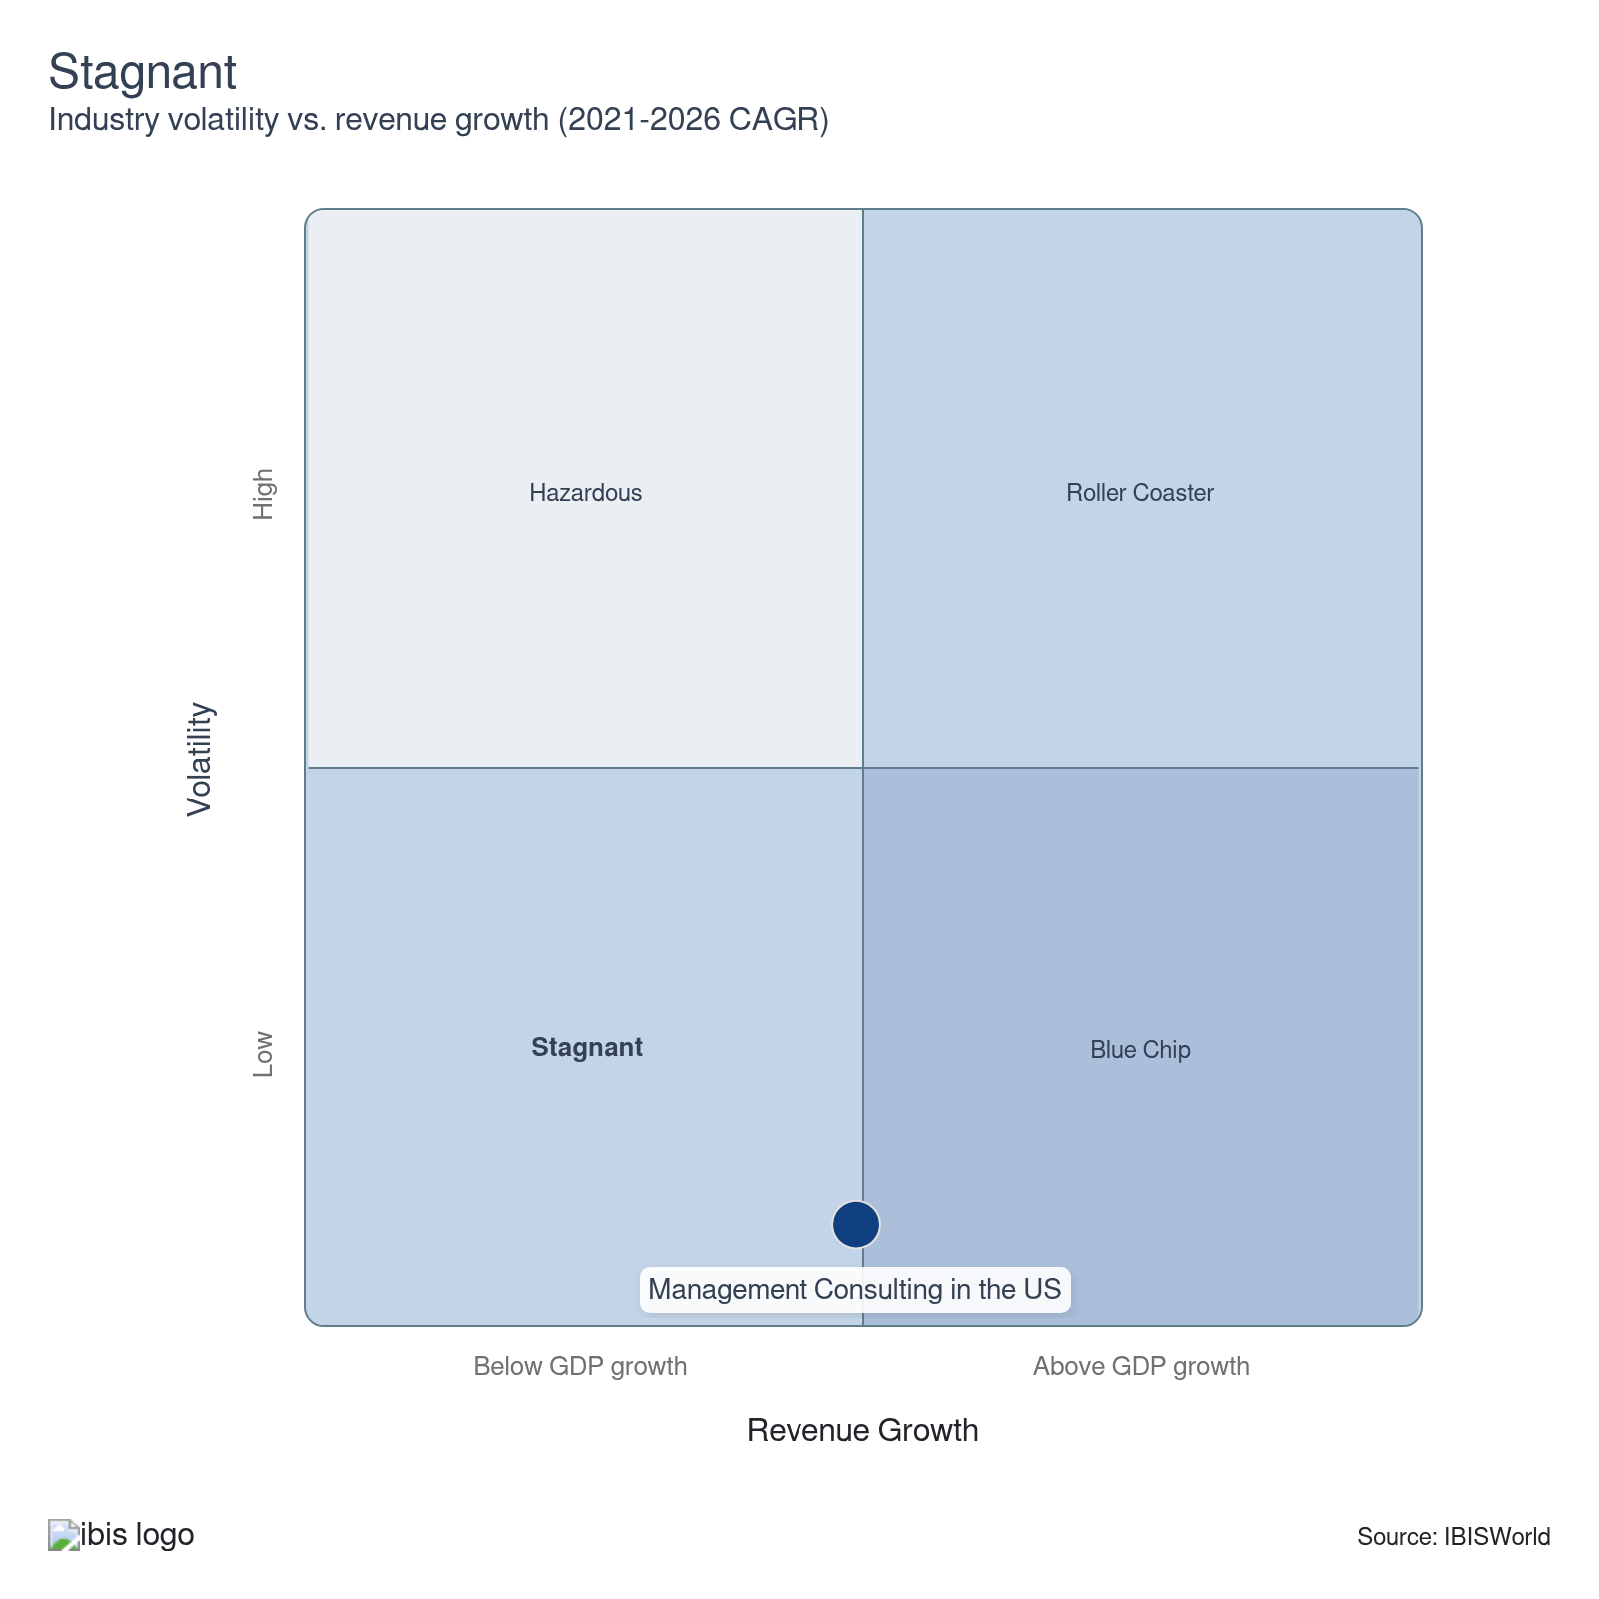

How do successful businesses overcome volatility?
Change or diversify markets
Diversifying client types across various markets can reduce revenue volatility and help companies weather economic disruptions. Management consultant skills are broadly applicable, allowing firms to mitigate risks associated with economic fluctuations.
Hire an experienced workforce
Management consulting firms can temper volatility by hiring an experienced agile workforce. This approach meets clients' changing needs in shifting environments, helping to stabilize operations and adapt swiftly to new challenges.
Outlook | ↑ 2026-31 Revenue CAGR +1.0%

What's driving the industry outlook?

Economic stabilization will offer niche opportunities for specialized consultants
- Economic expansion and stabilization across the business and professional services space will be critical factors that influence future revenue growth. Consultants are heavily reliant on the quantity of physical businesses available, as it provides a wider range of service opportunities. With 81.1% of consultants functioning as nonemployers, growth across individual businesses, which is poised to rise 1.0% over the next five years, will accelerate the market for newcomers into the industry.
- As the level of concentration increases, competitive forces that challenge profit by increasing input costs or placing downward pressure on prices will also spur companies to hire consultants. US businesses will continue to target emerging economies as export markets for business expansion. According to the Bureau of Economic Analysis (BEA), American assets invested across international markets grew from $39.56 trillion in Q2 2025 to $41.27 trillion in Q3 2025. Increasing globalization of downstream companies and growing competitive pressures will foster a need for consulting expertise in international matters like global acquisition planning, revenue forecasting and predictive analysis.
- Continued recessionary threats and an evolving tariff landscape will prompt some companies to limit spending, cutting back on management consulting services. Others will seek specialized consultants to generate growth in niche revenue streams like corporate strategy and risk assessment. Specialization is necessary, as it helps smaller consultancies protect against competitive threats by providing timeliness, quality and validity in client consultations.
- Smaller consultancies will be forced to increase service specialization if they are to secure a steady revenue stream from clients. Tangible actions include strategic acquisitions of rival firms that are experts in a particular field. For example, a local consultancy firm seeking to expand its marketing expertise will be encouraged to acquire local marketing consultant experts.

The continued proliferation of new technology will accelerate technical consultant specialization
- The emergence of big data and health tech wearables will continue generating lucrative opportunities for consulting services in the healthcare and science sectors. Managing the various healthcare sector regulations increases the need for experts in IT strategy and sales consulting. The public's increasing use of digital payments, cryptocurrencies and other financial technologies will spark interest in consulting by financial services companies.
- A future roadblock that will continue to generate expert IT strategy and sales consultant demand is the lack of consumer trust in new digital payment platforms. According to 2025 data from CivicsScience, 69.0% of individuals have low trust in cryptocurrency’s usability or reliability. As wider adoption of new crypto technology and tools expands, financial firms and retailers alike will look to contract qualified consultants to devise strategies on how best to incorporate these tools in their workflow.
- Private sector investment in IT will forge ahead via innovative tools like artificial intelligence, Internet of Things and cloud computing platforms. The expanded digital landscape will enhance management consultants’ service focus toward incorporating advanced IT systems. The expansion of new technology, such as blockchain, which offers a decentralized storage of client data, will incentivize companies to beef up their innovative muscle and secure long-term consultancy contracts to stay ahead of the innovative wave. Incumbent consultancies can do this by pursuing pay-for-access contracts, which allow a consultant to provide services over a set time period and remove the requirement for meeting set parameters.
- Government consumption and investment are expected to grow at a CAGR of 1.0% over the next five years, offering public sector clients with more funding for new projects. Outsourcing R&D to companies will impact the management consulting sector, as consultants' revenue is linked to government spending via public sector consulting demand. Higher rates of spending will also result in more involvement from vertical industries such as financial firms and industrial clients, as their services will be used to help facilitate new project completions. Consultants with specialization in project management and long-term corporate strategy will be in high demand.

Generative AI will continue to change consultants' staffing needs
- Many management consulting firms have already begun embracing generative AI tools like ChatGPT, while others have started to feel the pressure of heightened competition from AI tools. Vertical contenders such as Google’s Gemini and DeepSeek are offering lower-cost alternatives, which can benefit technically specialized consultants working on reworking a client’s internal IT design. With labor costs making up half of all expenses in 2026, management consultants will focus on scaling AI infrastructure for tasks such as data processing to reduce wage expenses and bolster revenue growth.
- AI tools can perform basic research and writing work that would normally fall to entry-level employees. This has already allowed consultants to focus on higher-level work, but it creates questions of how to better use low-level employees. This may also change the types of skills firms look for in new hires. According to a January 2025 report from Deloitte, 11.0% of clients feel like AI is efficient across internal operations, highlighting the value added of expanding AI across different consultancies.
- A core benefit of AI is the boost in productivity and efficiency that it's poised to provide, particularly among digitally oriented consultants that digest significant amounts of data. According to a report from Gartner, 50.0% of business decisions will be assisted by or conducted by agentic AI by the end of 2027. By enhancing workflow productivity, consultants can expect significantly improved outcomes in meeting project goals and delivering quality client results.
- Incumbent consulting companies are already making the long-term pivot by investing in internal AI infrastructure. In June 2025, major consulting service provider RSM US LLP announced a $1.0 billion investment into agentic AI technology across its core services catalog. The company is embracing DASH, a fully automated platform that can help generate insights and planning strategies for client requests.

Ease of entry allows consultants to meet and benefit from external shocks
- With consultancies facing limited barriers to entry, new competitors will continue to put downward pressure on incumbent consultancies, as clients will continue prioritizing quality service and pricing. IT innovations that increase competition in downstream markets will prompt companies to enlist the industry's services concerning process and operations management, corporate strategy and organizational design consulting.
- The number of enterprises is expected to grow at a CAGR of 2.9% over the next five years. Many of these companies will be small-scale nonemployers able to meet demand increases from economic shocks. This is beneficial for collective industry growth, as a more competitive marketplace ensures companies will prioritize service quality and accuracy for their clients, creating a race to the top in relation to competitive standing.
- However, clients will prioritize larger consultancies looking for quality assistance on time-crunch projects, such as a new merger or investment. Future economic uncertainty will be a giant accelerant in how frequently consultants will be contracted, particularly amid a rapidly changing tariff landscape and recessionary fears driving client interest in accurate guidance. To achieve long-term market visibility, consultancies can invest capital into promotional campaigns, allowing them to strengthen market visibility in concentrated markets and secure favorable terms with their client base.
- The diversified service offerings and client accessibility will allow small bespoke firms with a human-focused ethos to emerge in the coming years, especially as advancing technology removes some of the initial start-up costs. Continued proliferation into face-to-face consultations will accelerate smaller consultancies’ reach, as businesses and consumers look for expert advice prior to pursuing a business expansion or new acquisition.
Life Cycle | Mature

Why is the industry mature?

Contribution to GDP
Management consulting steadily contributes to GDP, as evidenced by its established role in aiding business operations and strategy across a wide range of sectors. Over the past decade, management consulting has grown at a faster pace compared with US GDP, fueled by strong corporate profit growth and greater consulting needs following tariff implementation.

Market Saturation
Management consultants face limited market saturation. With low barriers to entry, new companies can rapidly enter and meet needs driven by economic changes. While strategic marketing consulting services make up the most saturated service segment, the wide range of services offered across different sectors, such as finance and IT, offers a wide range of opportunities for new and existing consultants.

Innovation
Although management consultants are involved among tech-heavy clients, there's limited service-oriented innovation due to the services' client-facing nature. While innovation continues, it is less disruptive and more incremental, focusing on refining existing practices rather than pioneering new ones. Most innovation is driven by artificial intelligence (AI) and cloud systems implementation, which helps reduce manual labor reliance and bolsters data security.

Consolidation
Establishment growth is accelerating, with many small firms emerging and nonemployers making up over 80.0% of physical establishments. However, economies of scale drive mergers, acquisitions and consolidation among larger consultancies, strengthening their market position. Due to their fiscal strength, brand-name consultancy groups, such as Deloitte, have greater success expanding their market influence.

Technology and Systems
Management consultants are heavily reliant on digital systems and technological tools to accelerate efficient workflow practices and provide quality client service. Consultants quickly adopt new technologies, such as artificial intelligence (AI), to meet client needs and empower faster processing of large quantities of data.

4. Products and Markets
https://my.ibisworld.com/us/en/industry/54161/products-and-markets
Largest Market  $223.5bn  Strategic management consulting, and consulting combined with implementation | Product Innovation  Moderate

Key Takeaways
- Providing corporate strategy services remains a popular and wide-ranging service. These services see the greatest demand among consulting offerings and are a key driver of client growth irrespective of their sector or business.
- Client diversification opens niche opportunities. Serving a diverse client base, from private financial companies to public government organizations, allows consultants to specialize in niche consulting offerings and creates consistent revenue streams.

Products and Services
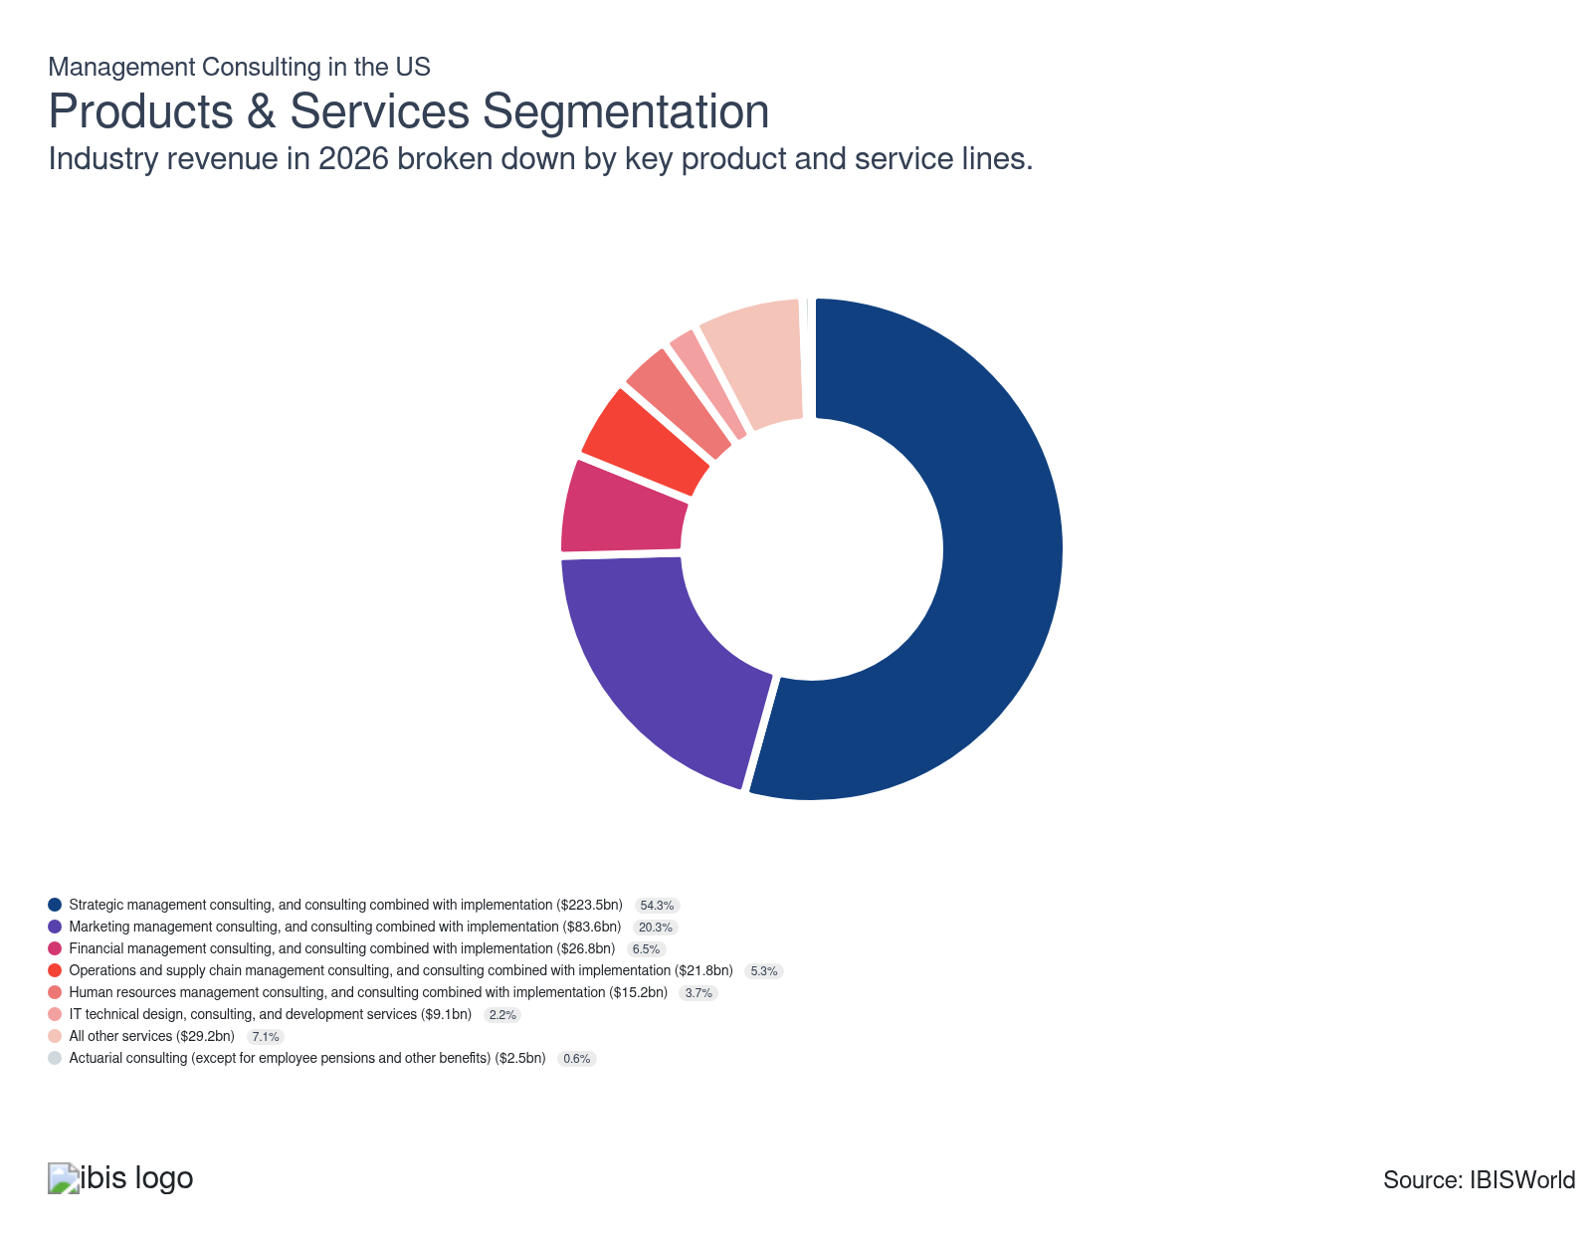

How are the industry’s products and services performing?

Macroeconomic volatility drives greater in-house competition against strategic management consulting services
- The strategic management consulting and the consulting combined with the implementation segment make up the most robust revenue stream for consultants. Core services include strategic advisory in the areas of general growth strategy, leadership development, performance improvement, mergers and acquisitions (M&A) and corporate portfolio design.
- Businesses, corporations and commercial clients across sectors such as finance, industrial and retail are the highest recipients of these services. Companies are always in demand of qualified strategic planners that can effectively guide company strategy toward a new market or assist in facilitating a strategically beneficial acquisition.
- Nonetheless, recent volatility in the Business Sentiment Index, which fell 4.2% over the past five years, harmed the segment by causing many businesses to shift their strategic planning toward in-house alternatives. The downstream effects of elevated interest rates and new tariffs made it more expensive to procure external consulting services, bolstering in-house competitors. While larger corporations in competitive spaces, such as Apple and JP Morgan Chase, remain an integral part of consultants’ workflow, smaller-sized businesses have pivoted away from external consultants in an attempt to preserve capital.

A growing digital advertising pivot enhances marketing management consulting service demand
- Marketing management consulting services involve guidance and assistance on advertising campaigns, brand redesigns and conducting broader market research to gauge consumer interests and appeals. Companies frequently need qualified consultants to boost their visibility and brand awareness across a wider market scope.
- For instance, a corporation such as Costco seeking to enter an international market may hire marketing management consultants to determine the proper approach to maintain the company's foundational values and branding while adapting to the culture of the foreign market.
- Economic conditions improved via a 3.5% boost in private investment in 2025, which provided greater leverage for clients to outsource marketing-oriented consultations to a professional consulting firm. The digital pivot in marketing and advertising strategies has also provided a swathe of lucrative revenue streams for technically proficient marketing consultants.

Slumping M&A activity curtails financial management consulting demand
- The financial management consulting segment includes finance-oriented services, such as working capital management and risk management, which assist clients in crafting financial forecasts and conducting due diligence prior to pursuing a new investment or financial action. Additional services involve guidance on mergers and acquisitions (M&A).
- While financial management is more substitutable than other services, companies often rely on external consultant support to receive unbiased, third-party guidance prior to conducting an internal action. Companies seek out consultants well-versed in financial modeling and future financial forecasts if their sector is prone to macroeconomic volatility or shifts in financial policy, such as interest rate fluctuations.
- Lower rates of M&A activity weakened demand for financial management experts and consultants well-versed in M&A intricacies, such as due diligence and post-merger integration planning. According to E&Y, the oil, gas and chemicals sector saw a 78.6% decline in new M&A deals, shrinking from 14 in January 2025 to three in January 2026.

Supply chain stabilization dampens operations and supply chain management service demand
- Operations and supply chain management consulting involves the provision of process, physical distribution and logistics consulting. Under the heading of logistics consulting, production scheduling and supply chain management form a consistent source of revenue for management consultants.
- Multinational corporations with global outreach are heavily involved in contracting consultants with expertise in supply chains and operational know-how. Retailer-facing clients such as Nike and Apple are heavily reliant on an efficient, resilient supply chain to ensure global production runs smoothly and that new products arrive in markets efficiently.
- The sharp plummet of the Global Supply Chain Pressure Index (GSCPI) from 3.60% in April 2022 to 0.49% in February 2026, per the New York Fed, underscores the rapid stabilization of supply chains via lower levels of global stress. This dampened external consultant demand for operational supply chain guidance.

A steady national labor market provides consistent revenue stream across HR management consulting segment
- The human resources (HR) management consulting segment involves consulting services that focus on inter-company workflow and strong company-employee relations. Consultants with HR expertise are frequently hired if a company is looking to expand its workforce or to strengthen internal company conditions.
- Fluctuations in the labor market are the biggest determinant of broader HR services demand. According to the BLS, the national unemployment rate inclined from 4.2% in February 2025 to 4.4% in February 2026 amid uncertainty surrounding interest rates and new tariffs. Companies have adapted accordingly, cutting down broader demand for HR specialists in line with labor market shifts.

The expansive variety of technical substitutes constrains demand for IT technical design services
- The IT technical design and consulting segment primarily comprises IT experts in fields such as cybersecurity, cloud computing and user interface (UI) development. Clients across different sectors procure IT consulting to bolster their technological efficiency and provide maximum protection of client data.
- Although the proliferation of technology has significantly altered how sector clients, particularly those within the financial and healthcare spaces, store and share consumer data, IT technical design remains a limited revenue stream for consultants. The availability of low-cost substitutes, such as UI designers, coupled with the expansion of new technology, such as blockchain, dampened the need for external consulting services.
- Nonetheless, niche IT design consultants with expertise in cybersecurity generate steady demand. In 2024, Dhanani Group announced a partnership with Deloitte to advance the adoption of new cybersecurity technology to protect the company’s data and supply chain from cyber attacks.

A diverse range of financial alternatives curtails actuarial consulting demand
- The actuarial consulting segment comprises risk assessment. Due to their robust presence across global investment and capital markets, clients in the financial space are the biggest users of these services. Consultants with actuary experience are valuable components of companies’ risk management teams, as they provide critical guidance on how risky a potential investment or financial move is.
- Although the role of consultant actuaries touches a key market, the segment makes up the smallest share of revenue due to the wide variety of substitute services available for clients. Financial companies, such as banks and investment firms, are far less likely to procure external actuary consultants because they desire to maintain oversight over risk assessment.

An emphasis on quality internal workflows maintains steady demand for miscellaneous consulting services
- Some of the miscellaneous services offered by management consultants cover niche topics, such as management accounting and organizational development. These services are limited to larger corporations and businesses, which look to procure these services to gain a second overview of their financial records and organizational efficiency.
- Corporations looking to ensure accounting standards are up-to-date and that organizational workflow is running smoothly hire consultants to act as guides in finding ways to improve workflow efficiency and strengthen adherence to existing accounting standards. Major companies, such as Accenture PLC, offer individualized operating services for businesses to enhance organizational efficiency.
- While miscellaneous services do offer lucrative returns for consultants, elevated interest rates caused many corporate clients to look for alternative service providers in an attempt to preserve capital.

What are innovations in industry products and services?

Digital transformation and artificial intelligence (AI) continues to drive service enhancements
- Management consultants are embracing digital tools and data analytics to drive transformation. These tools allow businesses to optimize operations, enhance customer experiences and innovate new product offerings. Major companies, such as Deloitte, also hold quarterly surveys gauging the use of AI across their workflow and adjacent sectors, highlighting the widespread expansion of automated technology that has exhibited over the past five years.
- According to a January 2026 report from Deloitte, 84.0% of companies are accelerating their annual investment into artificial intelligence (AI). Companies are taking advantage of the wider availability of robust technology to accelerate data gathering, insight write-ups and reduction of manual labor input. Agentic AI is a major innovation within the automation sphere that goes beyond content generation and can accomplish multi-step tasks. For example, operations and supply chain consultants can incorporate agentic AI to capture supply chain data and craft automated solutions in reducing a company’s bottlenecks.
- With data analytics, consultants provide actionable insights that help clients make informed decisions quickly, improving efficiency and competitive advantage. Integrating digital solutions enables real-time monitoring and rapid adjustments, making businesses more agile in responding to market changes.

What products or services do successful businesses offer?
Provide superior after-sales service
Effective after-sales support ensures client satisfaction and loyalty, fostering long-term relationships and repeat business via a commitment to client success. Consultants can leverage this reputation to attract new clients over their competitors.
Be an early adopter of new technologies
Management companies can enhance their services by adopting new technology, which increases value for clients by strengthening existing services’ workflow efficiency and making offerings more comprehensive and attractive to new clients.

Major Markets
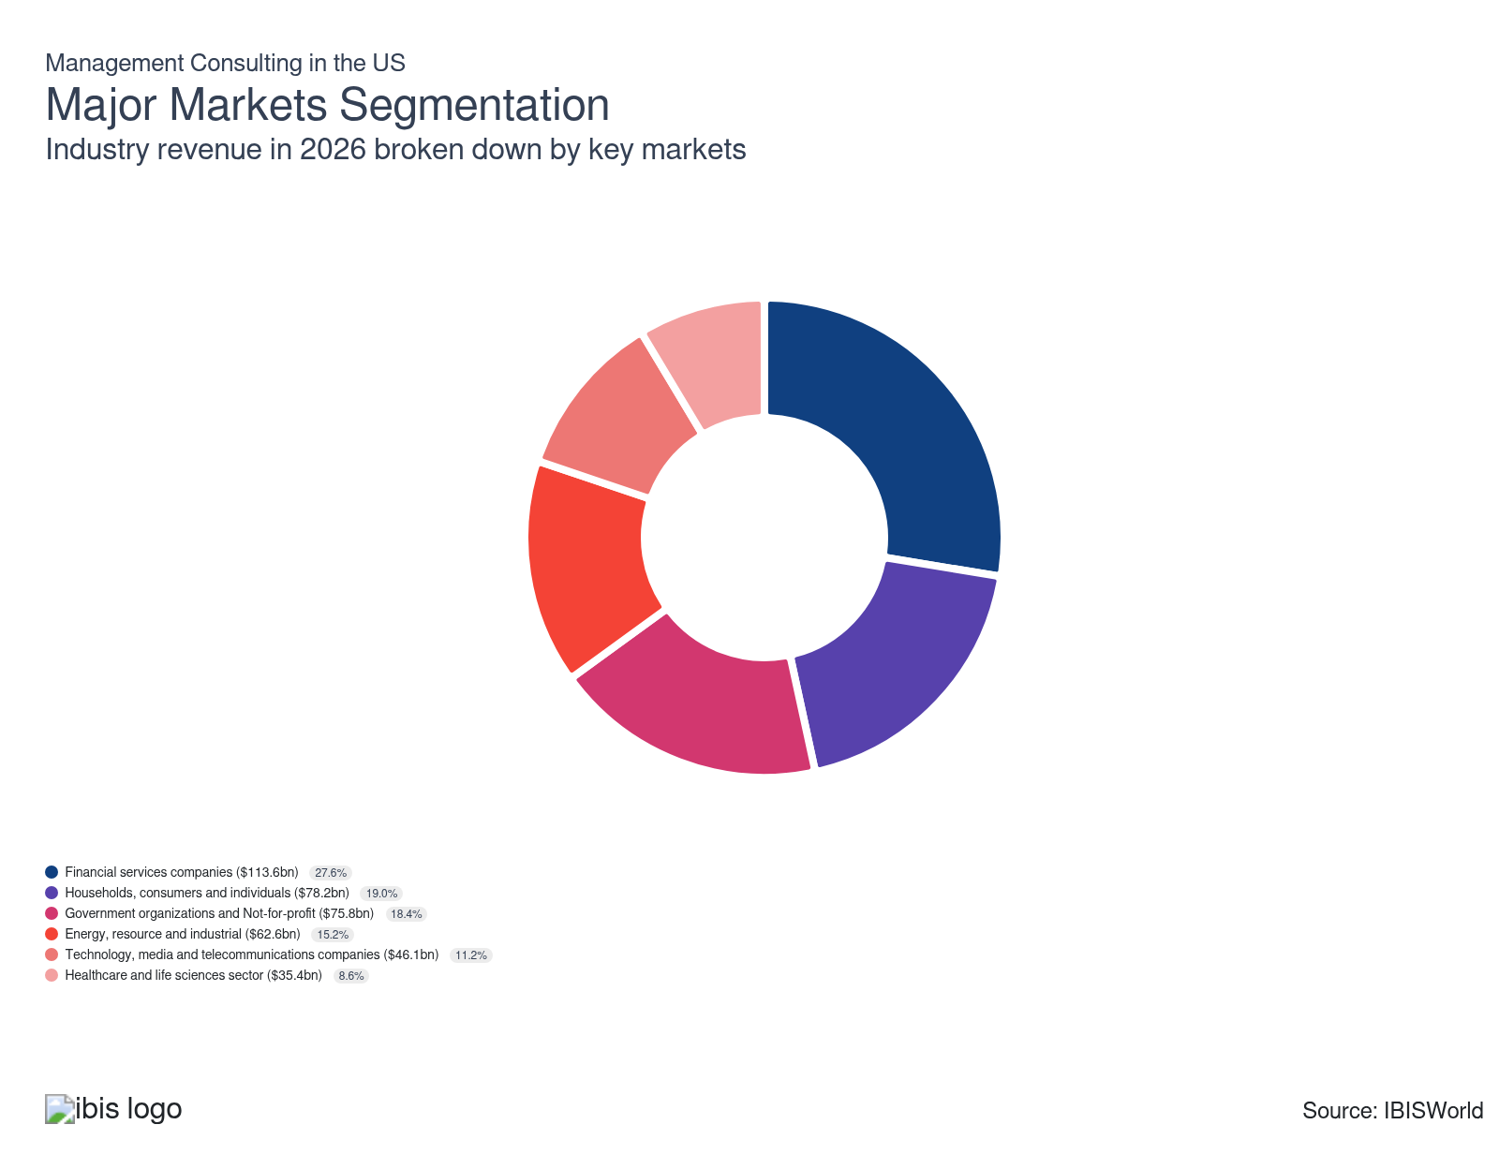

What’s influencing demand from the industry’s markets?

Rate cuts provide critical respite for financial companies to procure professional consulting services
- The financial services segment comprises financial sector companies ranging from national banks such as Citibank to investment platforms such as Robinhood. Collectively, the financial sector makes up the largest and most lucrative revenue stream due to their diversified array of consulting needs.
- Larger financial firms often consult management consultants if they want to run a new advertising campaign, shift their corporate strategy to invest in a new market or offer a new financial product to consumers.
- Rate cuts in 2025 brough national interest rates down to 3.6% as of February 2026, strengthening clients’ bargaining capability to procure a professional consultant. Commodity price volatility amid the US-Iran conflict in 2026 strengthened demand for corporate strategy and strategic consulting services, as financial companies sought professional advice on how to navigate these evolving conditions.

Economic stabilization results in steady consultant demand among individual consumers
- Households, consumers and individuals make up the second-largest share of revenue across the industry. Although consultants are primarily contracted by businesses and larger organizations, some individual clients, such as nonemploying businesses and sole proprietorships, contract consultants to advance strategic business goals.
- Individuals request consultant services primarily to facilitate quality marketing campaigns and improve HR operations. Since nonemploying and sole proprietorships have far less room for error in allocating resources to expand business visibility, consultants are critical partners in helping individual customers achieve their goals cost-efficiently.
- Slippage in national interest rates, which fell to 3.6% as of February 2026, boosted individual customers’ propensity to procure professional consulting services. However, in-house channels remain the largest competitive threat and ate into the segment’s revenue stream, albeit at a slower pace due to professional consultants’ technical and market knowledge.

Budget constraints and lack of expertise spur consults for government organizations and not-for-profit clients
- Government organizations and not-for-profit clients rely on management consultant services to advance federal and state-level research initiatives. Strategic planning and HR management consulting are integral services across the segment, as these clients look to procure expertise that is more cost-efficient than training or providing sophisticated analysis and services in-house.
- Government agencies' hiring of consultants, particularly at the state level, expands based on outsourcing research and development to the private sector and depends on changing government budgets. State funding for R&D expenditures across all sectors and functions inclined from $3.0 billion in FY 2023 to $3.3 billion in FY 2024, according to the National Science Foundation.
- State clients’ growing need for strategic planning and IT implementation services enhanced public sector demand for consultants specializing in new technology. However, the segment faces future uncertainty amid looming federal budget cuts. In the FY 26 budget proposal, basic research funding is slated to plummet from $44.7 billion to $29.6 billion, per the American Association for the Advancement of Science.

Accelerating energy price volatility create strategic planning needs across energy, resource and industrial clients
- The energy, resource and industrial clients segment requires consultant services to advise on the best corporate strategies during high price oscillations. Large oil companies, such as ExxonMobil, frequently contract consultants to craft long-term strategies for energy production projects and gauge new investment feasibility.
- Because global macroeconomic volatility has direct implications for oil prices and broader energy costs, consultants are in constant demand to keep clients informed. Global conflicts like the Russia-Ukraine conflict in 2022 and US-Iran conflict in 2026 bolstered energy market volatility and drove higher demand for energy strategy and planning consultants.
- Federal government activity and international conflicts are key drivers of energy strategy consultations. In November 2025, the Trump Administration executed a 900.0 million oil barrel purchase aimed at restocking the Strategic Petroleum Reserve (SPR). However, the outbreak of the US-Iran conflict in 2026 exacerbated global oil prices, forcing oil companies and industrial clients to update their energy strategy in response to new market trends.

Growing competition across do-it-yourself (DIY) channels dampens consultant demand across the technology segment
- The technology, media and telecommunications space relies on management consultant services to advance strategic interests and produce quality marketing schemes to attract downstream clients. Some prominent companies within the space include large tech firms such as Apple and telecommunications providers such as Verizon.
- The segment's client-facing nature creates a consistent need for quality recommendations on ways to efficiently target and advertise new technological advances, such as the latest iPhone model, to core downstream markets. The global outreach of digital technology also influences global supply chains, generating higher demand for professional consultants providing supply chain management consultations to ensure efficient processing and deliveries.
- Nonetheless, a 4.2% slump in the Business Sentiment Index over the past five years harmed confidence in hiring external consultants. Higher in-house competition across larger tech firms’ workflow generated competitive saturation that reduced segment revenue. The advance of new technologies, such as artificial intelligence (AI), allowed tech and media firms to shift more of their strategic workflow in-house.

In-house competition curtails demand across healthcare and life sciences segment
- Healthcare and life sciences clients make up the smallest revenue stream for management consultants due to their habit of adopting in-house consultation for issues such as marketing and strategic planning. Because healthcare clients deal with significant quantities of sensitive consumer data, they look for more internal oversight within the planning process.
- Nonetheless, the segment does generate niche opportunities for consultants specializing in technology and the adoption of new IT products within the workplace. For example, in 2024, AstraZeneca continued its expansion of electronic product information (ePI) in a coordinated partnership with Deloitte, per data from the 2024 Deloitte Global Impact Report.
- Higher in-house consultation competition and a wider expansion of digital competitors via AI adoption curtailed healthcare clients’ interest in external consultant services. Larger healthcare providers like hospitals continue to prioritize data privacy and internal oversight.

International Trade

Some industries don't directly import or export goods. See reports at the manufacturing level for international trade data on relevant products.

5. Geographic Breakdown
https://my.ibisworld.com/us/en/industry/54161/geographic-breakdown

Key Takeaways
- Consulting firms are primarily located in population centers like the Mid-Atlantic and the West. Major cities like Los Angeles and New York City are home to considerable business activity, enabling a lucrative and consistent regional demand stream for consultancies.
- Florida houses a significant share of management consulting firms. The Southeast leads the nation in the number of these firms, with Florida representing the majority in the region due to its favorable tax environment and heavy financial sector presence.

Business Locations
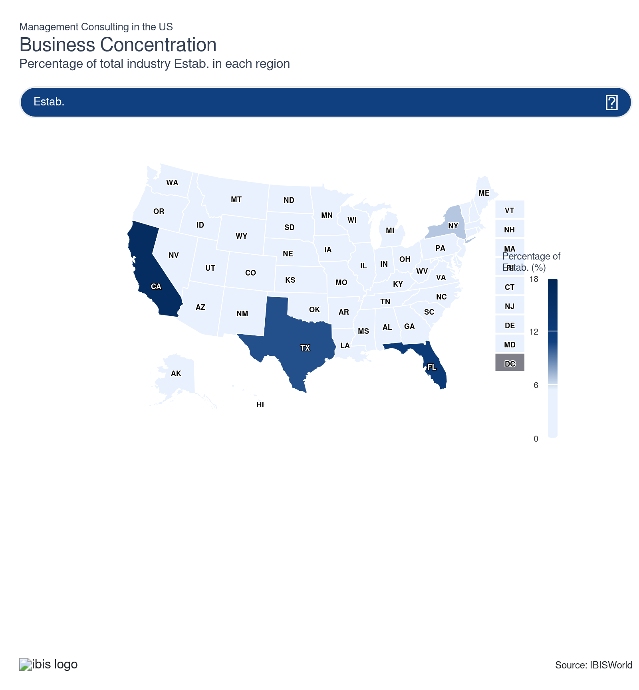
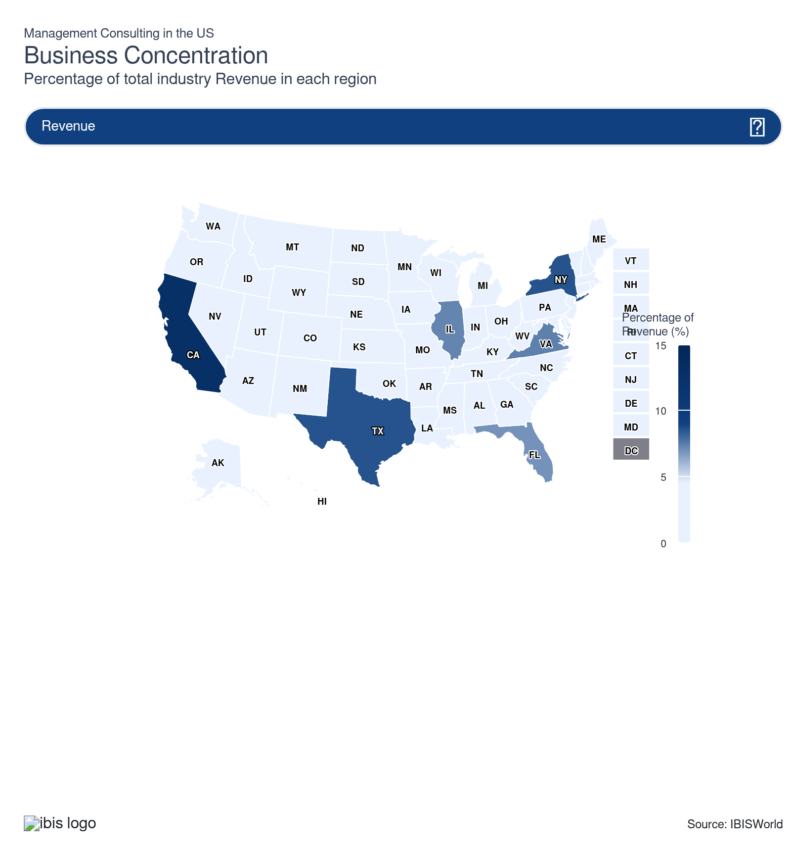
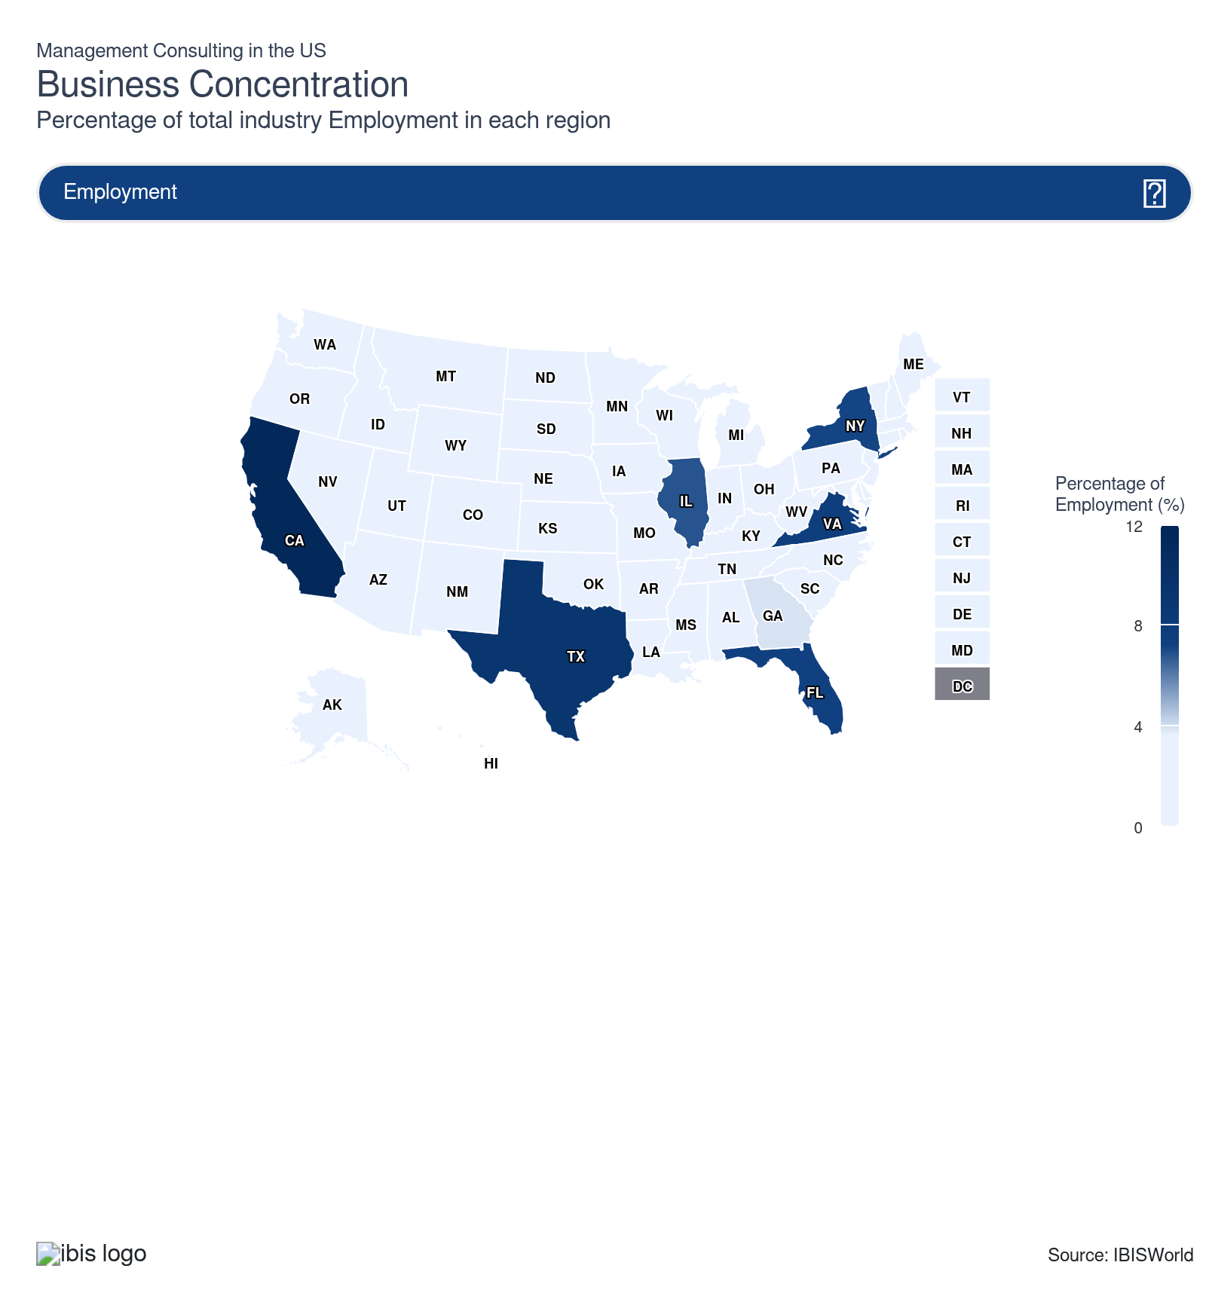
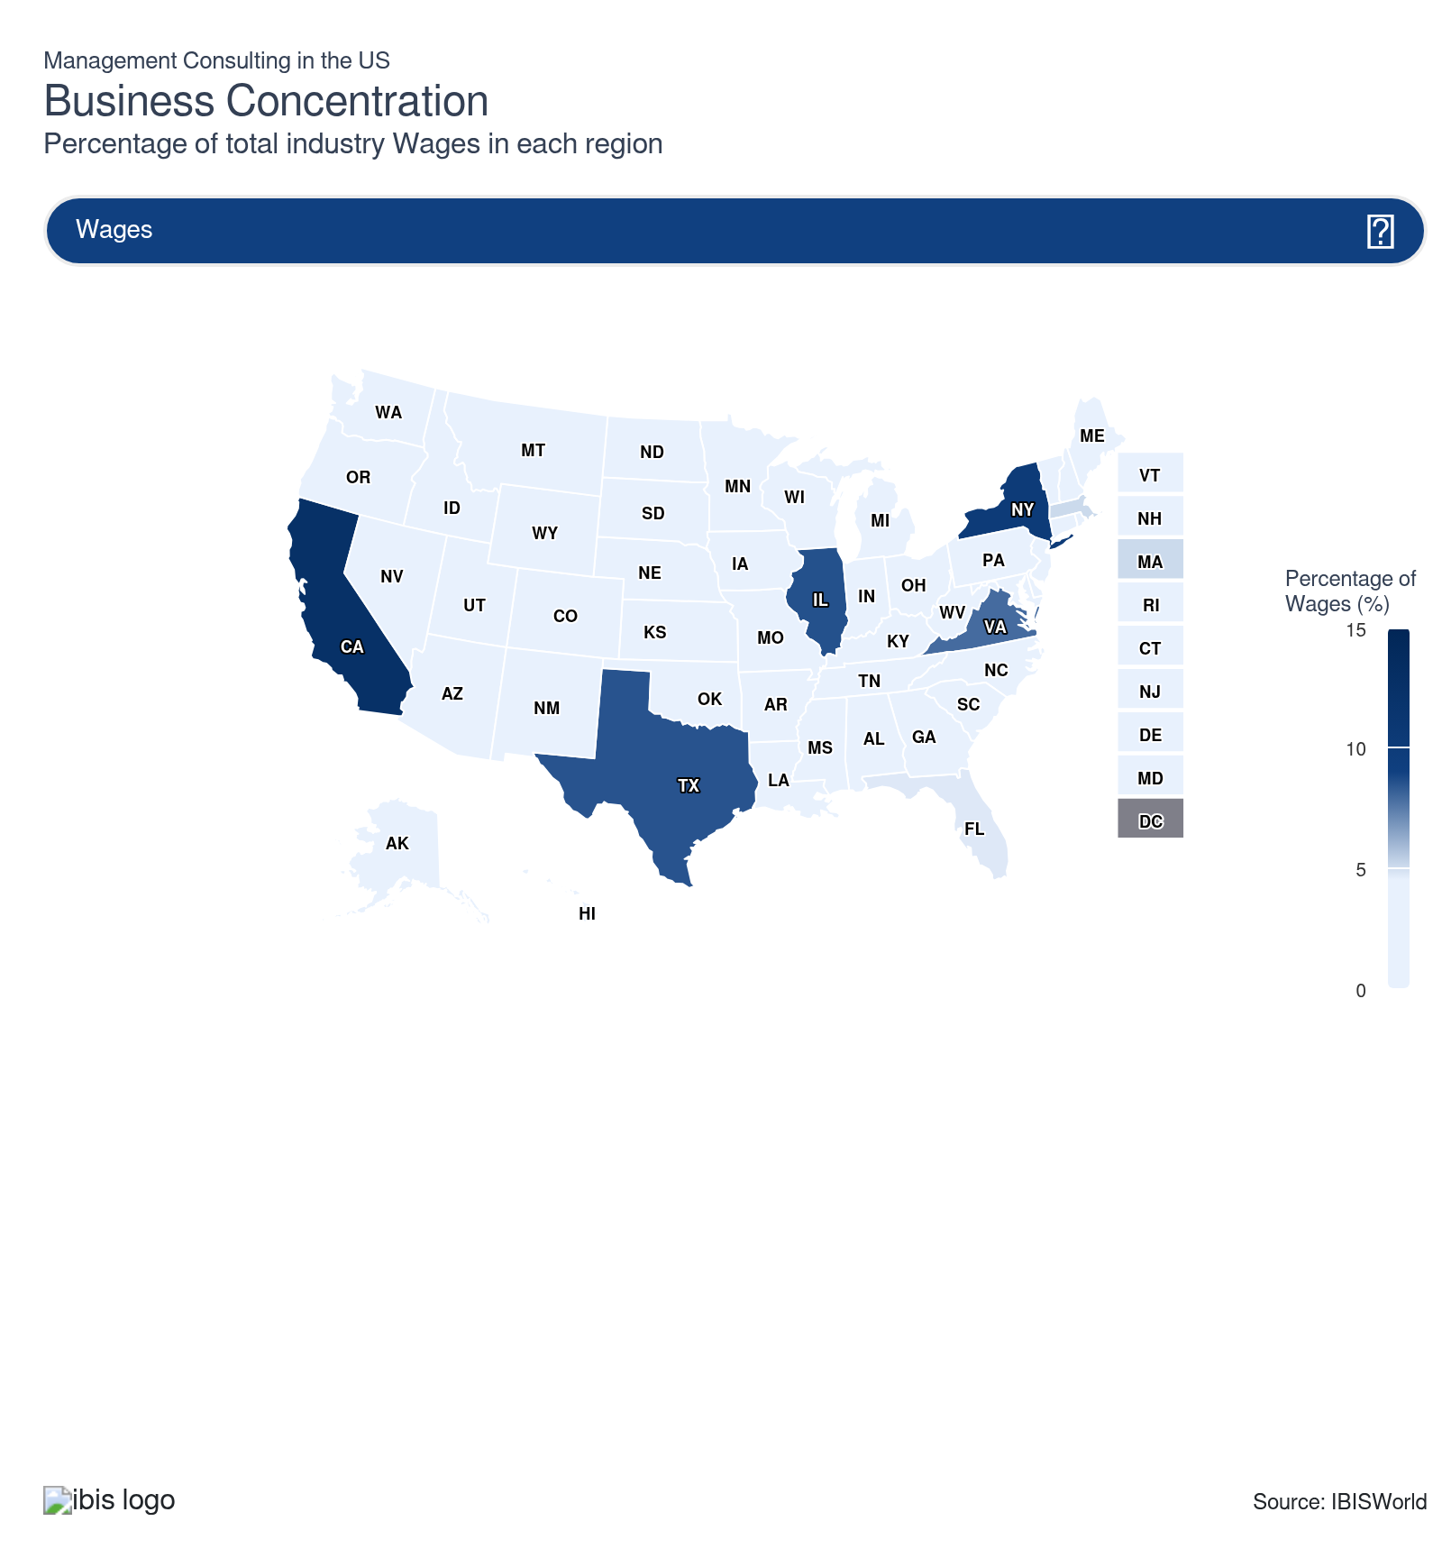
State | Estab.  Units | Estab.  % | Revenue  $m | Revenue  % | Wages  $m | Wages  % | Employment  Units | Employment  % | Population  %
California | 179,855 | 16.1 | 51,866.5 | 12.6 | 25,882.2 | 12.5 | 281,965 | 11.4 | 11.5
Texas | 115,394 | 10.3 | 35,147.6 | 8.5 | 17,554.7 | 8.5 | 225,011 | 9.1 | 9.4
Florida | 140,523 | 12.6 | 28,495.8 | 6.9 | 9,737.7 | 4.7 | 178,822 | 7.2 | 7.0
New York | 74,535 | 6.7 | 35,113.1 | 8.5 | 20,871.0 | 10.1 | 175,999 | 7.1 | 5.8
Virginia | 39,067 | 3.5 | 30,384.2 | 7.4 | 16,298.1 | 7.9 | 185,649 | 7.5 | 2.6
Illinois | 46,411 | 4.2 | 29,801.6 | 7.2 | 17,700.2 | 8.6 | 168,222 | 6.8 | 3.7
North Carolina | 42,791 | 3.8 | 11,566.3 | 2.8 | 4,428.4 | 2.1 | 69,067 | 2.8 | 3.3
Massachusetts | 21,990 | 2.0 | 15,269.8 | 3.7 | 10,518.0 | 5.1 | 84,858 | 3.4 | 2.1
Georgia | 42,386 | 3.8 | 16,298.2 | 4.0 | 7,738.5 | 3.8 | 95,932 | 3.9 | 3.3
New Jersey | 34,355 | 3.1 | 15,860.3 | 3.9 | 7,125.0 | 3.5 | 77,613 | 3.1 | 2.8
Colorado | 40,300 | 3.6 | 8,814.8 | 2.1 | 4,395.0 | 2.1 | 53,913 | 2.2 | 1.8
Pennsylvania | 30,252 | 2.7 | 13,143.6 | 3.2 | 7,800.5 | 3.8 | 89,058 | 3.6 | 3.8
Maryland | 24,284 | 2.2 | 11,023.0 | 2.7 | 6,559.0 | 3.2 | 84,235 | 3.4 | 1.8
Arizona | 30,292 | 2.7 | 6,802.7 | 1.7 | 2,752.7 | 1.3 | 48,243 | 2.0 | 2.2
Michigan | 22,375 | 2.0 | 10,405.7 | 2.5 | 5,353.4 | 2.6 | 76,810 | 3.1 | 3.0
Washington | 27,349 | 2.4 | 8,783.9 | 2.1 | 6,220.9 | 3.0 | 62,789 | 2.5 | 2.3
Utah | 28,784 | 2.6 | 4,822.2 | 1.2 | 1,612.6 | 0.8 | 34,153 | 1.4 | 1.0
Ohio | 24,158 | 2.2 | 10,055.3 | 2.4 | 4,499.5 | 2.2 | 65,917 | 2.7 | 3.5
Minnesota | 18,832 | 1.7 | 5,904.5 | 1.4 | 2,821.8 | 1.4 | 33,708 | 1.4 | 1.7
Tennessee | 14,789 | 1.3 | 4,623.5 | 1.1 | 2,586.1 | 1.3 | 40,903 | 1.7 | 2.1
Nevada | 19,221 | 1.7 | 3,238.3 | 0.8 | 1,145.2 | 0.6 | 22,576 | 0.9 | 1.0
Missouri | 12,789 | 1.1 | 4,507.8 | 1.1 | 2,164.5 | 1.0 | 40,173 | 1.6 | 1.8
Indiana | 15,677 | 1.4 | 4,295.4 | 1.0 | 1,910.6 | 0.9 | 36,126 | 1.5 | 2.0
Connecticut | 9,116 | 0.8 | 4,111.1 | 1.0 | 2,339.9 | 1.1 | 20,767 | 0.8 | 1.1
South Carolina | 12,868 | 1.2 | 4,110.7 | 1.0 | 1,690.4 | 0.8 | 35,009 | 1.4 | 1.6
Oregon | 14,094 | 1.3 | 2,912.0 | 0.7 | 1,250.3 | 0.6 | 20,236 | 0.8 | 1.2
Wisconsin | 12,058 | 1.1 | 3,977.9 | 1.0 | 1,582.2 | 0.8 | 27,284 | 1.1 | 1.7
Oklahoma | 10,354 | 0.9 | 1,624.3 | 0.4 | 695.9 | 0.3 | 16,322 | 0.7 | 1.2
Alabama | 8,319 | 0.7 | 1,983.9 | 0.5 | 776.0 | 0.4 | 16,610 | 0.7 | 1.5
Louisiana | 9,333 | 0.8 | 1,442.0 | 0.4 | 567.0 | 0.3 | 13,893 | 0.6 | 1.3
Kentucky | 8,143 | 0.7 | 1,893.1 | 0.5 | 554.9 | 0.3 | 13,551 | 0.5 | 1.3
Delaware | 6,620 | 0.6 | 1,459.2 | 0.4 | 729.5 | 0.4 | 10,709 | 0.4 | 0.3
Iowa | 5,954 | 0.5 | 1,873.5 | 0.5 | 692.4 | 0.3 | 14,387 | 0.6 | 0.9
Kansas | 7,232 | 0.6 | 1,658.2 | 0.4 | 713.5 | 0.3 | 14,340 | 0.6 | 0.9
Arkansas | 6,952 | 0.6 | 1,727.2 | 0.4 | 473.6 | 0.2 | 10,296 | 0.4 | 0.9
Wyoming | 7,831 | 0.7 | 876.8 | 0.2 | 206.5 | 0.1 | 7,831 | 0.3 | 0.2
Idaho | 7,120 | 0.6 | 1,000.8 | 0.2 | 365.5 | 0.2 | 9,697 | 0.4 | 0.6
Nebraska | 4,889 | 0.4 | 1,338.5 | 0.3 | 485.2 | 0.2 | 10,609 | 0.4 | 0.6
New Hampshire | 3,325 | 0.3 | 829.5 | 0.2 | 421.2 | 0.2 | 6,520 | 0.3 | 0.4
Montana | 4,964 | 0.4 | 387.2 | 0.1 | 96.1 | 0.0 | 4,964 | 0.2 | 0.3
Hawaii | 2,926 | 0.3 | 586.8 | 0.1 | 248.5 | 0.1 | 5,722 | 0.2 | 0.4
New Mexico | 3,300 | 0.3 | 705.0 | 0.2 | 230.4 | 0.1 | 5,355 | 0.2 | 0.6
Maine | 3,442 | 0.3 | 680.6 | 0.2 | 226.4 | 0.1 | 4,940 | 0.2 | 0.4
Mississippi | 2,962 | 0.3 | 539.9 | 0.1 | 213.0 | 0.1 | 5,932 | 0.2 | 0.9
Alaska | 1,525 | 0.1 | 532.9 | 0.1 | 236.2 | 0.1 | 4,842 | 0.2 | 0.2
Rhode Island | 3,134 | 0.3 | 476.9 | 0.1 | 187.5 | 0.1 | 4,923 | 0.2 | 0.3
South Dakota | 2,622 | 0.2 | 320.5 | 0.1 | 79.9 | 0.0 | 2,705 | 0.1 | 0.3
West Virginia | 1,729 | 0.2 | 352.1 | 0.1 | 128.9 | 0.1 | 4,074 | 0.2 | 0.5
Vermont | 1,887 | 0.2 | 273.7 | 0.1 | 85.1 | 0.0 | 1,913 | 0.1 | 0.2
North Dakota | 1,455 | 0.1 | 339.4 | 0.1 | 124.7 | 0.1 | 2,791 | 0.1 | 0.2

Where are industry businesses located?

Management consultants thrive in the Southeast due to a booming corporate market
- Lower living and operating expenses compared with other regions make the Southeast attractive for new consulting companies. This affordability helps firms manage overhead costs more efficiently, fostering consultant growth. Clients are in consistent need of consultations to advance business strategy and run effective marketing campaigns that can appeal to a wider downstream base.
- The Southeast is experiencing rapid business growth fueled by a business-friendly tax climate, especially in cities like Atlanta and Miami. According to the US Census Bureau, Florida saw a 7.4% boost in new business applications from January to February of 2025. The state also benefits from a tax-friendly fiscal policy, with no state income taxes attracting a wide variety of individuals and business clients. This vibrant business climate drives demand for management consulting services to support expansion, innovation and competitive strategies.
- The region's economic diversity includes vital sectors like finance, healthcare and logistics, creating varied opportunities for consulting companies. This diversity allows consultants to offer tailored solutions across different industries, boosting new establishment demand. Deloitte houses four major offices in Florida alone, driving continued revenue streams for consultants specializing in business strategy and corporate planning.

The West has an expansive business landscape that attracts consultants
- The West serves as a tech innovation epicenter, offering lucrative revenue streams for consultants specializing in IT design and marketing campaigns. Areas like Silicon Valley and Seattle offer prominent tech hubs for new consultants in the area, with revenue streams available across digital transformation and strategic growth channels.
- A thriving startup culture in cities like San Francisco and Los Angeles creates constant demand for expertise in scaling operations, organizational development and strategic planning, bolstering the presence of new management consulting establishments with organizational skills expertise. The state of California has been a huge accelerator in this regard, with 2025 data from Startup Frequency noting that 585 new startups were founded in California alone.
- California also serves as a prominent hub for consumer-oriented revenue streams. Major cities like Los Angeles house a robust individual population that requires consulting services for niche areas such as marketing and IT. The region also houses a range of prominent educational institutions, such as University of Southern California (USC) and UC Berkeley. Proximity to these institutions provides management consulting companies with access to a locally sourced and technically skilled workforce.

Robust consumer presence strengthens consultant demand in the Mid-Atlantic
- The Mid-Atlantic region primarily benefits from a mix of densely populated areas and a booming corporate market that drives demand for management consulting services. Prominent companies, such as Deloitte and McKinsey, are headquartered in New York City, offering access to a wide variety of consulting needs.
- States like New York also benefit from a competitive market, with the wide range of services offered by consultants providing a variety of opportunities for new entrants looking to secure a steady revenue stream. Some of the more popular service segments include strategic and marketing management consulting, as individuals and corporations alike require these services to plan ahead and effectively target new clients.
- Major consultancies have been active in expanding their Mid-Atlantic presence. In May 2025, Deloitte announced an office move that would see their US-based corporate headquarters located in Hudson Yards in New York City. McKinsey also unveiled a new office opening in Newark, New Jersey in December 2024. These office expansions and headquarter shifts underscore the efforts taken by major consultancies to expand their Mid-Atlantic footprint.
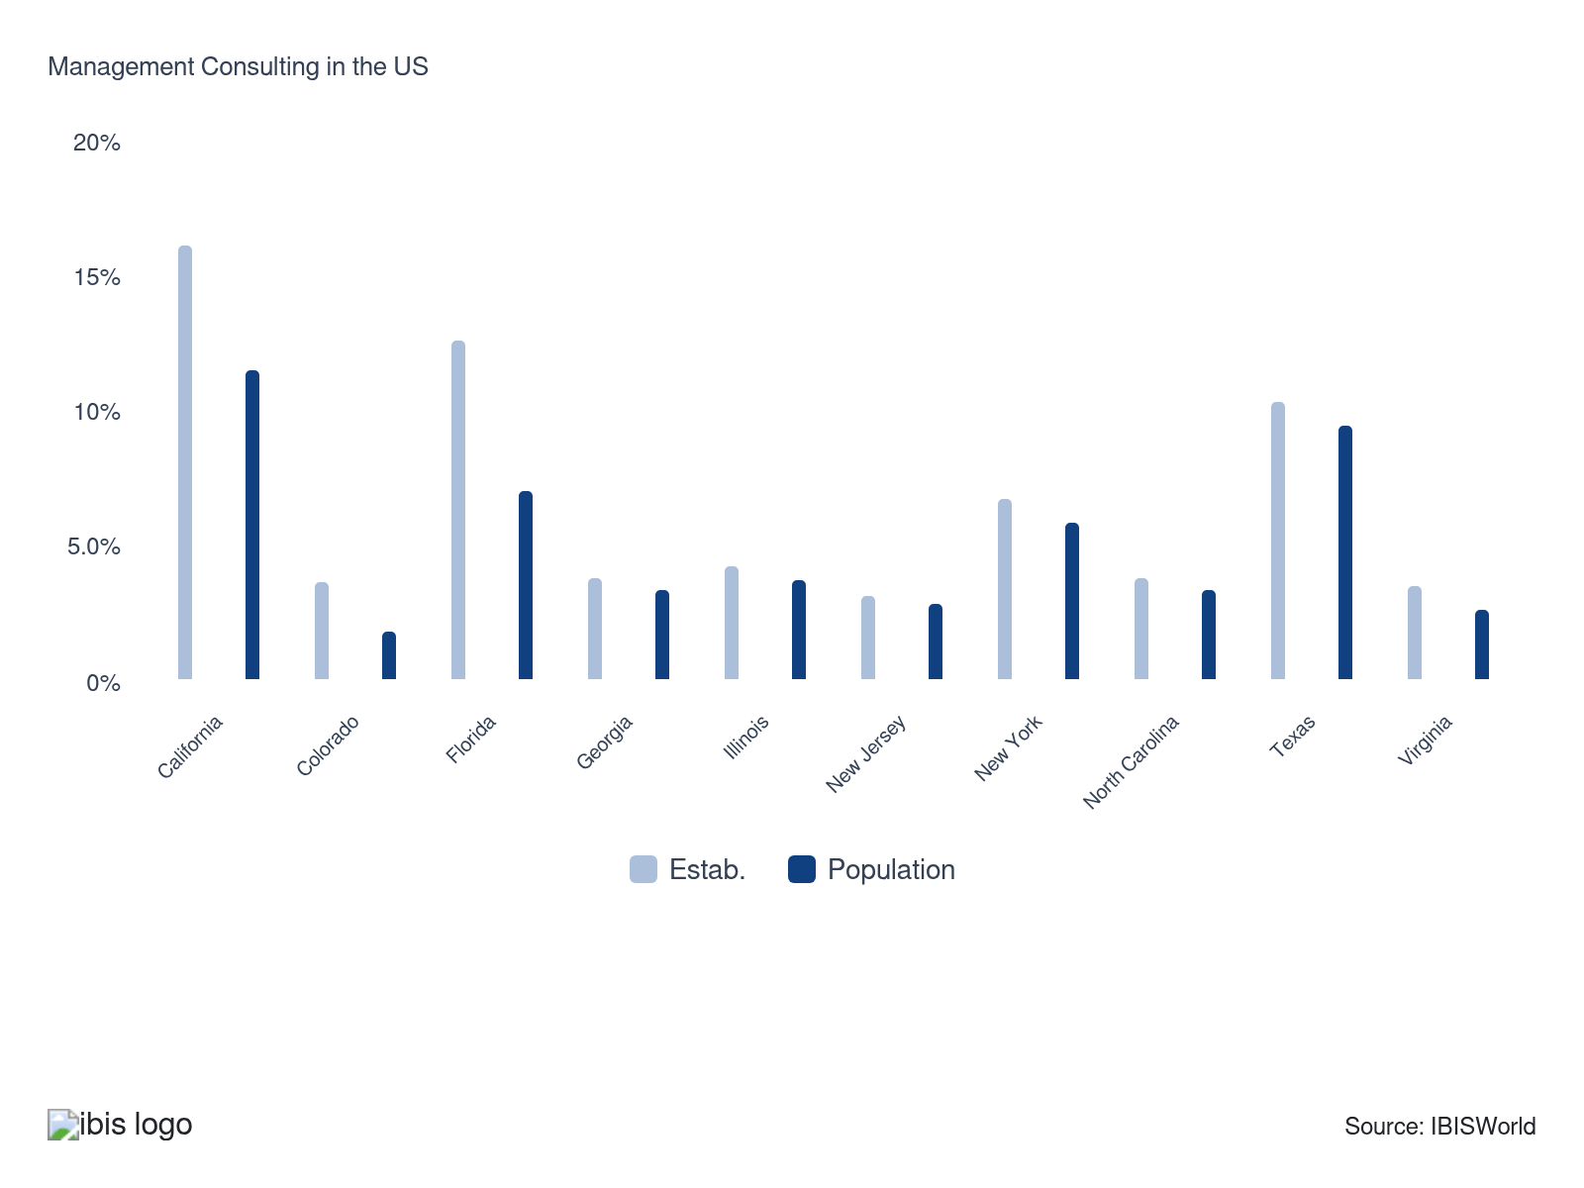

How do businesses use location to their advantage?
Ensure skilled labor is available
Management consulting firms often find it easier to attract skilled workers and experts when operating near universities or large metropolitan areas. These locations provide a rich talent pool and proximity to educational and professional resources.
Operate in a location that is close to key markets
For niche management consulting firms in healthcare or finance, locating near hospitals or finance centers is advantageous. The concentration of potential clients in these areas ensures a continuous and stable revenue stream.

6. Competitive Forces
https://my.ibisworld.com/us/en/industry/54161/competitive-forces

Key Takeaways
- Competition will tighten the industry's overall profitability. As technology impacts clients' businesses and boosts consulting demand, companies will need to spend more on skilled workers and automated infrastructure to keep up with external competitors.
- Fewer new management consultants will lead to a more concentrated market. Slower growth underscores the advantages of larger companies, while mergers allow smaller companies to combine resources and achieve economies of scale.

Concentration
Low
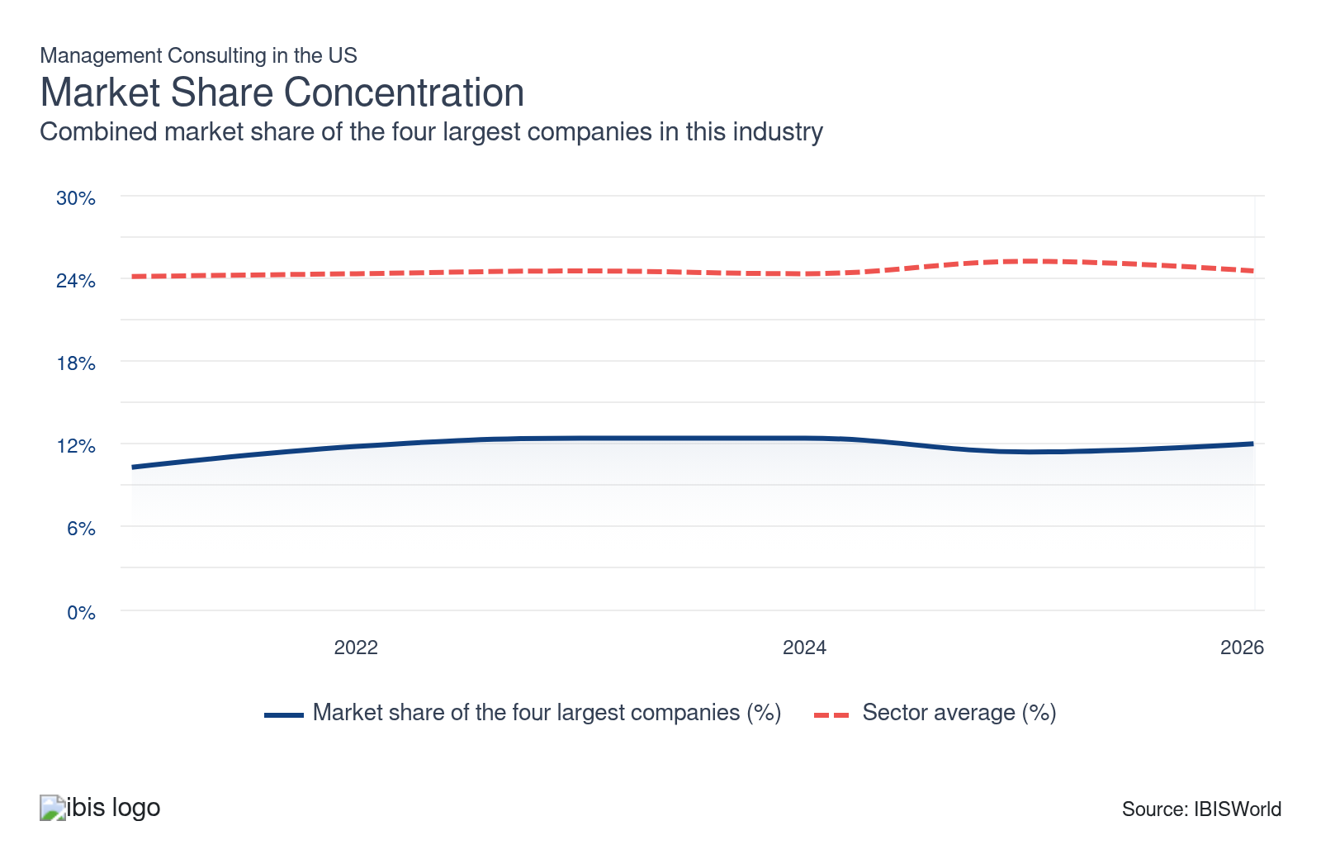

What impacts the industry’s market share concentration?

The success of niche entries reduces concentration
- There is high fragmentation across the landscape, with over 80.0% of all consultant establishments comprising small, nonemploying companies that serve narrow geographic or niche markets. Competition is kept at bay as they serve niche markets, allowing price stability and even pricing autonomy.
- While entry is difficult at a large scale due to the costs of attracting a large talent pool needed to service large projects, there are lower barriers to entry serving specialized markets and services.

New acquisitions offer greater influence within the strategic consulting space
- While there's no set leader across the management consulting space, incumbent companies with prominent brand names have been expanding their influence within niche sectors of the economy via strategic acquisitions in rapidly growing fields. In July 2025, Accenture PLC announced the acquisition of Maryville Consulting Group, which helped strengthen the company’s technology guidance and strategic planning service niche. In August 2025, Accenture also acquired The Highlands Consulting Group, strengthening the company’s consulting footprint in California.
- Acquisitions into internationally situated markets have also been integral in solidifying established companies’ market presence. In January 2025, Accenture PLC acquired AOX, a software firm based in Germany that provides software services for automakers. Accenture’s targeted acquisition activity aims to promote greater expansion of IT design and consulting services among automakers and car manufacturers, including a push to globalize its brand name.

Technology supports and incentivizes new entrants into the market
- Adopting technologies enabling remote service provision permits smaller firms to grow and expand by accessing a broader client base. At the same time, new technology, such as blockchain and cloud storage, allows entrants to flourish as the firms can more easily reach clients who value the firm's expertise.
- Data-sharing and communications cloud technology reduce the costs of mergers among smaller enterprises, bringing together experts to form teams that can service larger clients with varied and complex problems. Although this is more limited across more prominent companies such as Deloitte, smaller consultancies are investing more resources to adapt to an evolving technological landscape in an attempt to secure more clients.

How do successful businesses handle concentration?
Ability to compete on tender
Most consultancy tasks face stiff competition. For smaller consultants to compete with industry giants, offering competitive pricing and diverse service offerings is crucial.
Become a member of an industry organization
Larger companies are better known and attract more talent and clients. Connecting with industry organizations helps smaller firms access skilled labor and boosts their public visibility.

Barriers to Entry
Low | Steady

What challenges do potential industry entrants face?

Legal
- Management consultants must adhere to regulatory oversight and procure the necessary licenses. Securing necessary licenses and meeting regulatory compliance can be challenging and time-consuming, especially for new companies aiming to establish credibility in competitive markets. The most commonly sought-after license is the Certified Management Consultant (CMC) license, which provides training and profile authenticity to new consultants.

Start-Up Costs
- Entrance into the management consultant space requires purchasing the necessary tools and office space equipment to ensure consultants can effectively conduct their tasks. Start-up costs for management consulting include expenses for technology infrastructure, office space and initial marketing campaigns. However, the industry is not capital-intensive and the required capital expenditures to start a business are not prohibitive.

Differentiation
- There is considerable differentiation across the services offered by consultants. However, most service demand is derived from strategic and marketing consulting, making it difficult for newcomers to stand out in a crowded market. Establishing a unique value proposition demands significant investment in branding and specialized expertise, which favors incumbent consultants with a proven track record.

Labor Expenses
- Attracting and retaining top talent involves high salaries and benefits, adding a considerable financial burden, especially for smaller or emerging consulting companies. The higher-paid, most sought-after consultants obtain technical knowledge in rapidly evolving technologies and entrants will find it harder to hire them.

How can potential entrants overcome barriers to entry?
Access to highly skilled workforce
Consultants overcome labor barriers by offering competitive salaries and continuous professional development opportunities. This strategy attracts top talent and fosters long-term employee retention.
Access to niche markets
By leveraging advanced analytics and cutting-edge technologies, consultants provide unique insights into niche markets. These capabilities set them apart from competitors and establish them as experts in specialized fields.

Substitutes
Moderate | Steady

What are substitutes for industry services?

In House
- Companies often develop internal strategy teams to perform functions traditionally handled by management consultants. These teams provide continuity and deep organizational knowledge. Internal strategists can continuously work on long-term projects without disrupting external consultant turnover, fostering ongoing improvement and consistent vision alignment.
- Building internal teams can be cost-effective over time, though the initial recruitment and development of top talent may require significant investment. Larger companies with fiscal flexibility that dominate their respective sector, such as banks, may look to procure their own consultancy teams in an attempt to preserve capital and maintain oversight over sensitive data used in their projects.

Business software and analytics tools
- Advanced business software, including ERP and CRM systems, can replace some management consultant functions by automating processes and providing real-time data insights. These tools empower management to make informed decisions without external help, enabling tighter control over strategic initiatives and operational efficiencies.
- Analytics tools offer predictive insights and benchmarking capabilities, helping businesses stay agile and competitive. However, proper implementation and regular updates are crucial for effectiveness, making them difficult to scale as a robust alternative if specialists are not overseeing their use.

How do successful businesses compete with substitutes?
Invest in research and development
Staying ahead of the latest trends and developing innovative solutions to client needs ensures management consultants offer the latest, most efficient and cutting-edge services. Higher R&D investment differentiates consultants’ service offerings from direct substitutes, boosting their competitive edge.
Having good working relationships
Word-of-mouth and a reputation for timely, innovative service are crucial for gaining clients. Good working relationships can result in being hired over competitors for new projects, strengthening consultants' competitive edge.

Buyer & Supplier Power
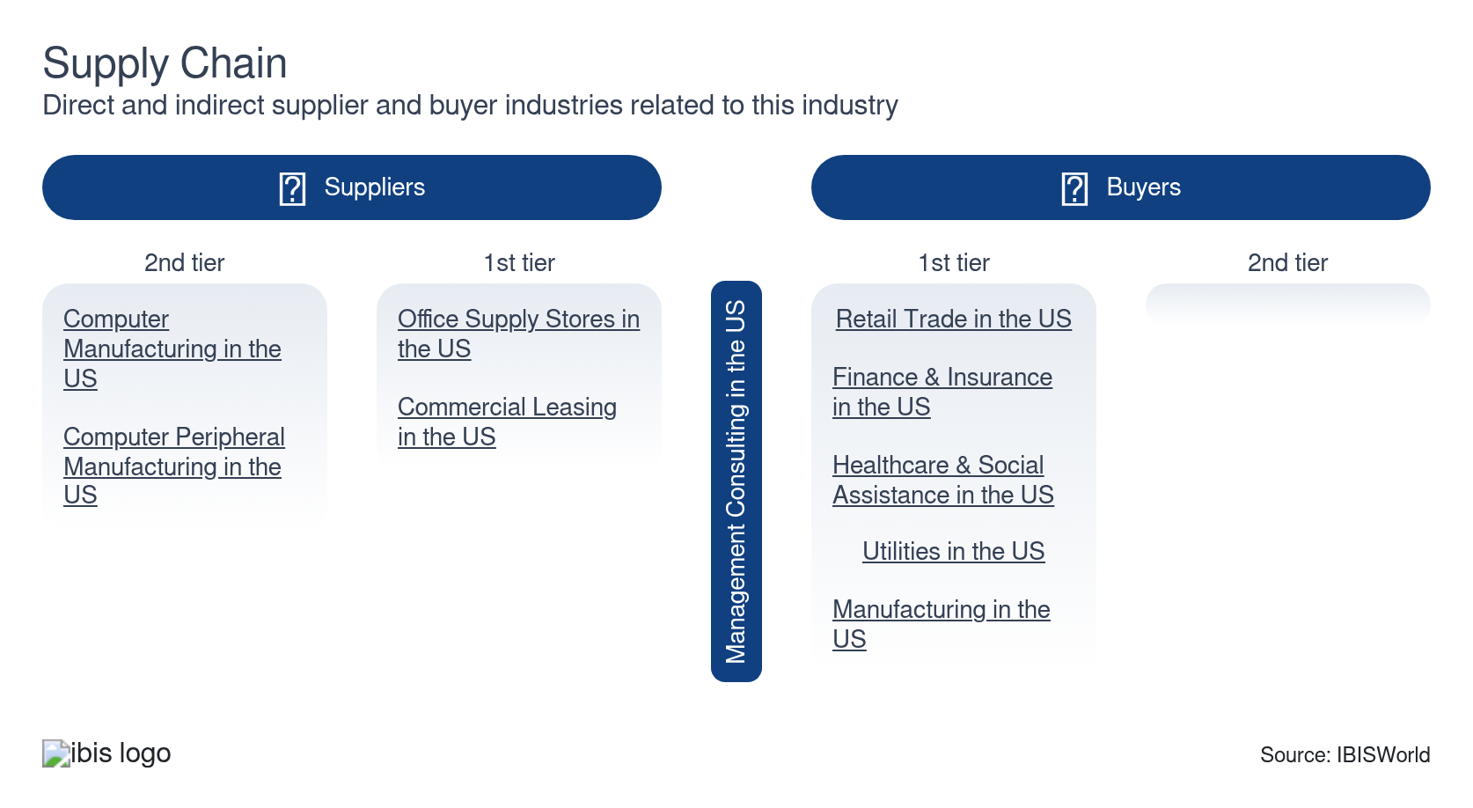

What power do buyers and suppliers have over the industry?

Buyers: Robust client size
High | Steady
- Due to the size and scope of their economic impact, buyers are extremely influential in the management consulting space. Consultants are consistently contracted across the public and private sectors, as clients seek professional advice and guidance on issues such as strategic planning and marketing strategies.
- Corporations seeking management consulting services often have the leverage to demand on-site consultants and tailor services to specific needs, significantly affecting project scopes and costs. Larger companies wield significant bargaining power, prioritizing consultants’ quality of service, brand name and pricing.
- The presence of internal strategy teams and alternative advisory services heightens buyer power to deliver superior value and innovative solutions. This increased competition pressures companies to continuously enhance their offerings to stay ahead in the market.

Suppliers: Advanced skillsets raise wages
High | Increasing
- Suppliers’ influence remains elevated due to the valuable machinery and equipment they procure for consultants’ services. Since most of the tasks conducted by consultants are done via computers, switching supplies can be expensive, as there are limited alternatives available to desktop computers and laptops.
- Larger consultant groups, such as Accenture PLC and Deloitte, have more leverage in negotiating with suppliers due to their availability of economies of scale. While higher costs of computer software are impactful, larger consultancies can pass these costs on to downstream clients when providing services.
- If an existing supplier contract already exists, it becomes difficult for a consultant to switch to an alternative, as the high costs associated with switching and securing a new contract make it fiscally unfeasible. Suppliers will continue to have an outsized influence across the industry as more advanced and powerful computers and software enter the market.

How do successful businesses manage buyer & supplier power?
Automate processes to reduce costs
Automating systems and implementing advanced technology allow consultants to dedicate more time to unique analysis at a competitive price, thereby reducing buyer power. This shift enhances service quality and diminishes clients' negotiating leverage.
Be willing to outsource when appropriate
With rising skilled labor costs, management consultants can mitigate supplier power by maintaining a pool of part-time trained workers available for hire as needed. This strategy provides flexibility and helps manage expenses.

7. Companies
https://my.ibisworld.com/us/en/industry/54161/companies

Key Takeaways
- Major companies offer various services beyond management consulting, allowing them to outcompete smaller firms, particularly with larger clients. Major companies such as Deloitte and Accenture PLC offer services such as technology consulting and sustainability assistance.
- Small companies compete by specializing. By targeting niche markets or offering specific services, these firms can leverage deep expertise to effectively compete against larger companies for client business.

Market Share
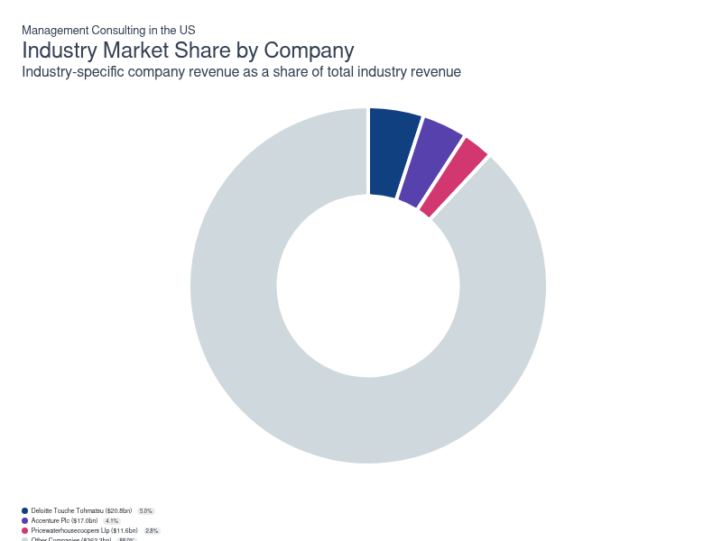
Chart displays current year only in the PDF version of this report. You can view and download chart for all other years associated with this industry on my.ibisworld.com.

Companies
Company | Market Share (%)  2026 | Revenue ($m)  2026 | Profit ($m)  2026 | Profit Margin (%)  2026
Deloitte Touche Tohmatsu | 5.0 | 20,778.6 | 2,284.3 | 11.0
Accenture Plc | 4.1 | 16,993.2 | 2,424.0 | 14.3
Pricewaterhousecoopers Llp | 2.8 | 11,585.4 | 1,273.7 | 11.0

Deloitte Touche Tohmatsu
Deloitte Touche Tohmatsu
Company Details
Company Details
Industry Specific Revenue (2026) | $20.8bn
Industry Profit (2026) | $2.3bn
Company Employees (2026) | 470,000
Market Share (2026) | 5.0%

Description
Description
Deloitte Touche Tohmatsu is a private company with an estimated 470,000 employees. In the US, the company has a notable market share in at least seven industries: Accounting Services, Management Consulting, Human Resources Consulting, Forensic Accounting Services, Oil, Gas & Mining Consultants, Pharmaceutical Contract Management Consulting, Audit Services and Management Consulting. Their largest market share is in the Human Resources Consulting industry, where they account for an estimated 24.6% of total industry revenue and are considered an Incumbent because they display strong market share, but lower profit and revenue growth than some of their peers.

Brands and Trading Names
Brands and Trading Names
- clearcarbon consulting
- DOMANI sustainability consulting
- Monitor group
- Recombinant by deloitte
- Rubix
- Ubermind

Other Industries
Other Industries
- Accounting Services in the US
- Audit Services in the US
- Forensic Accounting Services in the US
- Human Resources Consulting in the US
- Oil, Gas & Mining Consultants in the US
- Pharmaceutical Contract Management Consulting in the US

Company’s Industry Revenue, Market Share, and Profit Margin Over Time
Company’s Industry Revenue, Market Share, and Profit Margin Over Time
Year | Industry Revenue ($ million) | Market Share (%) | Profit Margin (%)
2008 | 1908 | 1.3 | 15.7
2009 | 2164 | 1.5 | 15.7
2010 | 2434 | 1.5 | 15.7
2011 | 3194 | 1.8 | 15.7
2012 | 4018 | 2.1 | 15.7
2013 | 4747 | 2.3 | 15.7
2014 | 5464 | 2.5 | 15.7
2015 | 6116 | 2.7 | 15.7
2016 | 6778 | 2.9 | 15.7
2017 | 7600 | 3.1 | 15.9
2018 | 8870 | 3.5 | 15.5
2019 | 9632 | 3.6 | 15.0
2020 | 10441 | 3.8 | 10.7
2021 | 10964 | 3.5 | 11.9
2022 | 14900 | 4.3 | 11.6
2023 | 20456 | 5.5 | 11.3
2024 | 22121 | 5.7 | 11.2
2025 | 18760 | 4.7 | 11.1
2026 | 20779 | 5.0 | 11.0

What's impacting Deloitte Touche Tohmatsu's performance?

Deloitte acquires cloud consulting firm, expanding its consulting business
- In March 2022, Deloitte acquired BIAS Corporation, enhancing its capabilities in cloud-based consulting services. This acquisition allows Deloitte to offer comprehensive cloud transformation and migration services, supporting clients in modernizing their digital infrastructure. With businesses increasingly relying on cloud solutions for critical operations, Deloitte is poised to expand its client base and strengthen its position in the cloud services market.

Deloitte unveils a major AI-backed consulting innovation
- In February 2026, Deloitte unveiled Enterprise AI, a fully automated platform that matches client needs with agentic AI solutions. The platform deepens Deloitte’s differentiation by combining consulting task analysis into a single, comprehensive system. Modular components like AI Identifier, Impact Analyzer, Workflow Designer, and Agent Studio create a pipeline of follow-on services that generate agentic solutions for each specific case and follow-up implementation. By embedding the tool into engagements, Deloitte standardizes clients' opportunity assessments, prioritizes use cases and scopes work, bolstering the company's technical specialization.
Accenture Plc
Accenture Plc
Company Details
Company Details
Industry Specific Revenue (2026) | $17.0bn
Industry Profit (2026) | $2.4bn
Company Employees (2026) | 779,000
Market Share (2026) | 4.1%

Description
Description
Accenture is a public company headquartered in New York with an estimated 779,000 employees. In the US, the company has a notable market share in at least 11 industries: IT Consulting, Management Consulting, IT Security Consulting, Insurance Claims Processing Software, Business Process Outsourcing Services, Supply Chain Management Services, Healthcare Consulting, Oil, Gas & Mining Consultants, Marketing Consulting, Energy & Utility Consulting Services, Distribution & Logistics Consulting Services and Management Consulting. Their largest market share is in the IT Security Consulting industry, where they account for an estimated 25.7% of total industry revenue.

Brands and Trading Names
Brands and Trading Names
- ?What IF!
- Adaptly
- Advocate
- Analytics8
- Apis Group
- Arz Allgemeines Rechenzentrum
- Avenai
- Avieco
- bionic
- ClearEdge
- Headspring
- Kates Kesler
- Mercer, Inc.
- Oliver Wyman Group
- Root Inc

Other Industries
Other Industries
- Business Process Outsourcing Services in the US
- Distribution & Logistics Consulting Services in the US
- Energy & Utility Consulting Services in the US
- Healthcare Consulting in the US
- Insurance Claims Processing Software in the US
- IT Consulting in the US
- IT Security Consulting in the US
- Marketing Consulting in the US
- Oil, Gas & Mining Consultants in the US
- Supply Chain Management Services in the US

Company’s Industry Revenue, Market Share, and Profit Margin Over Time
Company’s Industry Revenue, Market Share, and Profit Margin Over Time
Year | Industry Revenue ($ million) | Market Share (%) | Profit Margin (%)
2007 | 2395 | 1.8 | 14.6
2008 | 2779 | 1.9 | 14.6
2009 | 3024 | 2.1 | 14.6
2010 | 3424 | 2.1 | 14.6
2011 | 4312 | 2.4 | 14.6
2012 | 5275 | 2.7 | 14.6
2013 | 6099 | 3.0 | 14.6
2014 | 6946 | 3.2 | 14.6
2015 | 7679 | 3.4 | 14.6
2016 | 7914 | 3.3 | 14.7
2017 | 9342 | 3.8 | 14.4
2018 | 10094 | 4.0 | 14.6
2019 | 10353 | 3.9 | 14.7
2020 | 10902 | 3.9 | 14.7
2021 | 12302 | 3.9 | 15.1
2022 | 15334 | 4.4 | 15.2
2023 | 15126 | 4.1 | 13.7
2024 | 14938 | 3.9 | 14.8
2025 | 15798 | 3.9 | 14.7
2026 | 16993 | 4.1 | 14.3

What's impacting Accenture Plc's performance?

Accenture strengthens coordination with the federal government
- In 2024, Accenture announced securing a new $250 million contract from the federal government. This $250 million contract is a testament to Accenture's strong relationship with federal agencies, reinforcing its position as a trusted partner in public sector IT solutions. Enhancing BLM’s digital infrastructure expands Accenture's influence in the environmental and land management sectors, while boosting the proliferation of technologies like portal development and geospatial enablement. These capabilities ensure efficient land and mineral management, showcasing Accenture’s prowess in integrating cutting-edge technologies to solve complex government challenges.

Accenture Plc announces a strategic acquisition aimed at expanding consulting expertise
- In August 2025, Accenture Plc (Accenture) announced the acquisition of The Highlands Consulting Group. The consultancy was based in California and has extensive contacts across public agencies, such as Health and Human Services (HHS). The acquisition bolsters Accenture’s organizational change-management and strategic planning capabilities in complex public programs. Accenture also strengthens its public-sector footprint within California by absorbing Highlands’ long-standing agency relationships.

Accenture recently acquired a major consulting firm
- In 2024, Accenture announced the acquisition of Camelot Management Consultants. The acquisition has enriched Accenture's portfolio with Camelot’s proven supply chain and data analytics expertise. Clients can harness innovative, more intelligent, resilient supply chain practices, meeting new market demands effectively. Camelot’s experience in data strategy and AI adoption will support Accenture’s clients in their technological transformation. Accenture’s research indicates that only 9.0% of companies widely use AI in their supply chains; this strategic move will help bridge this gap and enhance profitability. By acquiring Camelot Management Consultants, Accenture significantly bolsters its SAP-focused offerings. This alignment amplifies Accenture’s ability to enhance AI-driven solutions in supply chain management, providing clients with robust, tech-savvy solutions.
Pricewaterhousecoopers Llp
Pricewaterhousecoopers Llp
Company Details
Company Details
Industry Specific Revenue (2026) | $11.6bn
Industry Profit (2026) | $1.3bn
Company Employees (2026) | 364,000
Market Share (2026) | 2.8%

Description
Description
Pricewaterhousecoopers is a private company headquartered in New York with an estimated 364,000 employees. In the US, the company has a notable market share in at least four industries: Accounting Services, Management Consulting, Forensic Accounting Services, Audit Services and Management Consulting. Their largest market share is in the Audit Services industry, where they account for an estimated 14.9% of total industry revenue and are considered a Rising Star because they display lower market share, but displaying stronger profit and revenue growth than some of their peers.

Brands and Trading Names
Brands and Trading Names
- PricewaterhouseCoopers
- PwC

Other Industries
Other Industries
- Accounting Services in the US
- Audit Services in the US
- Forensic Accounting Services in the US

Company’s Industry Revenue, Market Share, and Profit Margin Over Time
Company’s Industry Revenue, Market Share, and Profit Margin Over Time
Year | Industry Revenue ($ million) | Market Share (%) | Profit Margin (%)
2021 | 9051 | 2.9 | 11.9
2022 | 10432 | 3.0 | 11.6
2023 | 10242 | 2.8 | 11.3
2024 | 10947 | 2.8 | 11.2
2025 | 11135 | 2.8 | 11.1
2026 | 11585 | 2.8 | 11.0

You can view and download company details on my.ibisworld.com.

8. External Environment
https://my.ibisworld.com/us/en/industry/54161/external-environment

Key Takeaways
- Minimal barriers to entry spur competition for skilled employees in labor-intensive industries. With no significant obstacles to starting a business, the race for seasoned, highly trained and connected workers intensifies.
- Consultants must be skilled in new technologies. Expert knowledge of industry advances is crucial for providing sound advice and overseeing the implementation of client processes and procedures.

External Drivers

What demographic and macroeconomic factors impact the industry?
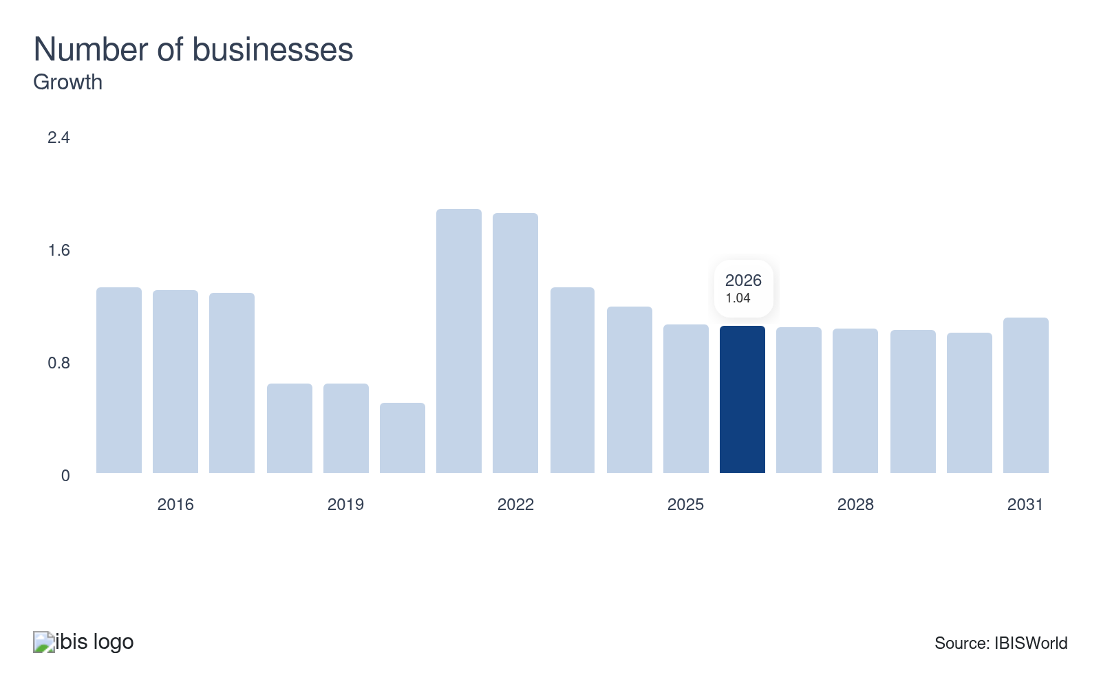
The number of businesses directly affects the potential market size for the management consulting industry. As the number of businesses grows, the pool of potential clients for management consultants expands, driving up the need for administrative, organizational and strategy consulting services. Economic stabilization and growth spur business proliferation, presenting a potential opportunity for management consultants to increase their client base.
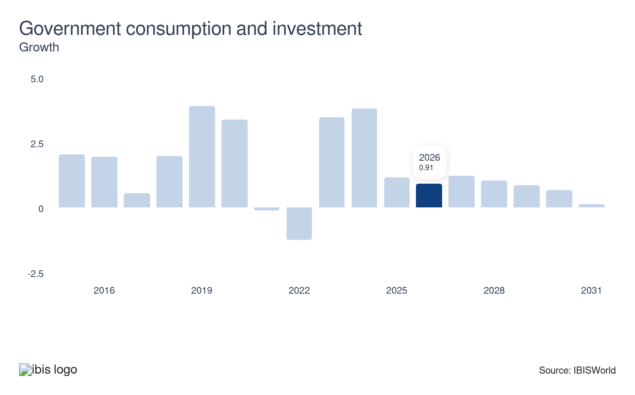
While the corporate sector generates most consultant revenue, government agencies also contribute significantly to the management consulting industry. Government spending drives public sector demand for consulting services, raising revenue by outsourcing research and development contracts. Most government demand is derived at the state level, as statewide agencies contract consultants to craft spending strategies and local marketing campaigns. Any sizable decrease in government consumption and investment reduces spending on consultants' services.
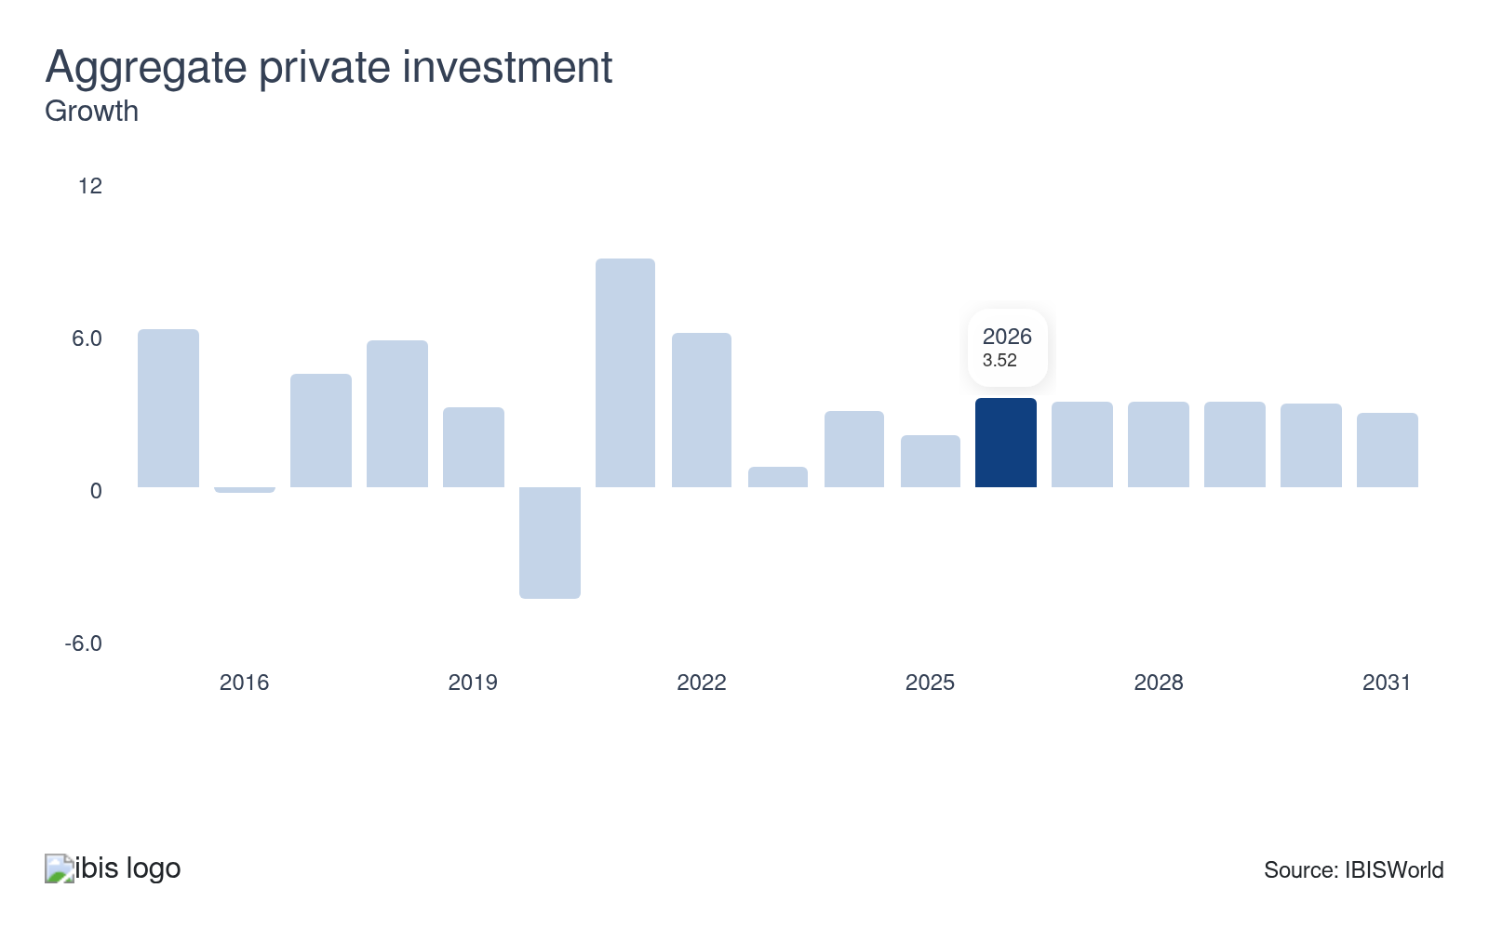
Aggregate private investment includes spending by individuals and businesses on physical structures, equipment and software. An increase in investment tends to boost revenue, as businesses use consulting services to strategize and understand what aspects of their businesses are most profitable and where investment must be focused. Conversely, falling private investment highlights a lower desire to procure consultants’ services.
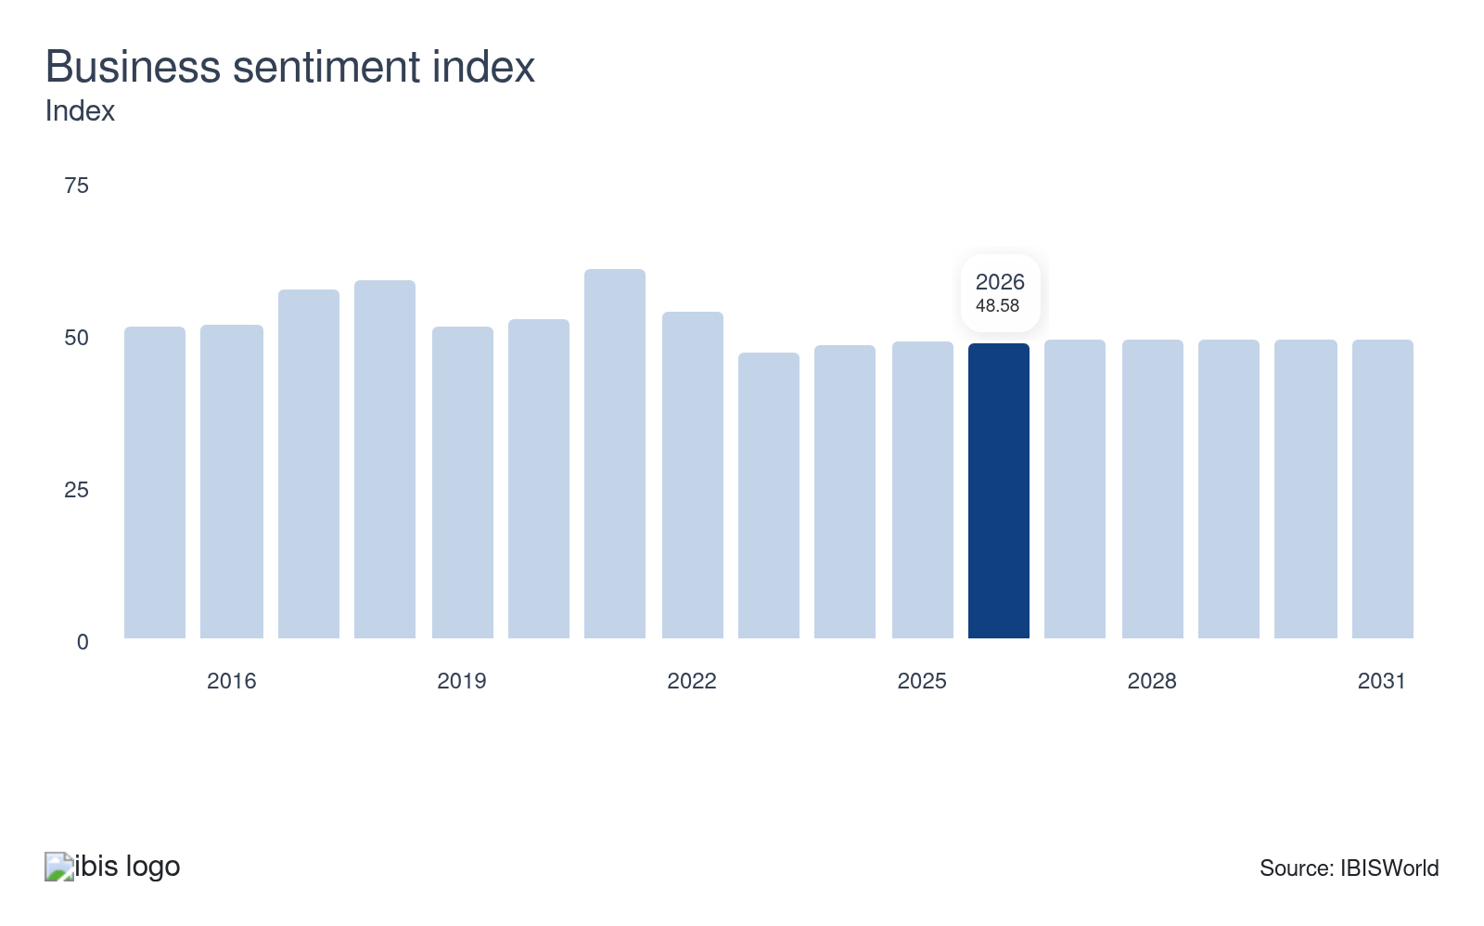
The business sentiment index measures the overall health of the business environment by evaluating production, inventory, supply deliveries and employment levels. When business sentiment decreases, businesses tend to contract spending, reducing expenditures on consulting services. Conversely, a rising business sentiment reflects robust fiscal health among companies and corporate clients, expanding the client pool for consultants.
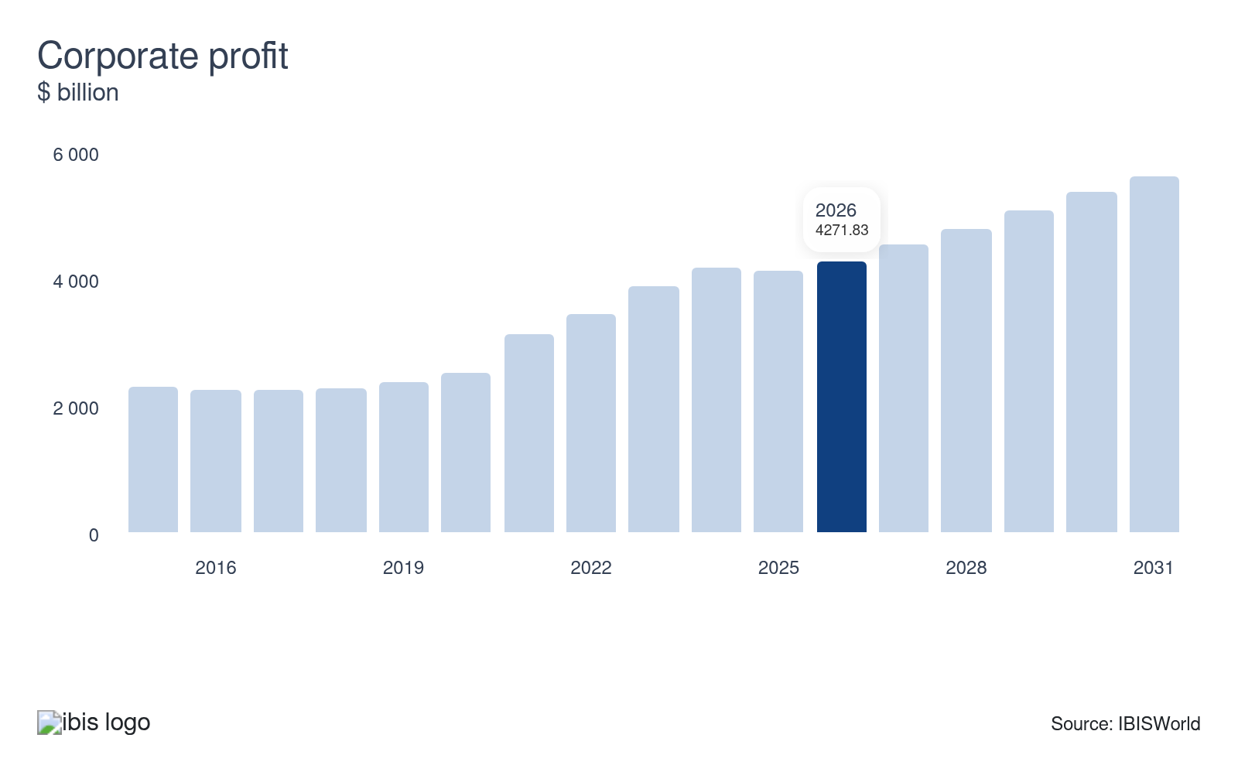
Increases in corporate profit enable companies to invest, expand and hire consultants. However, management consultants often benefit most when corporate profit declines. During downturns, businesses seek data-driven analysis and expertise to navigate economic uncertainty. Conversely, in prosperous times, demand for management consulting services can diminish, posing a potential threat to the industry as companies feel less need for external guidance.

Regulation & Policy
Low | Steady

What regulations impact the industry?

Sarbanes-Oxley Act of 2002
In response to the Enron scandal and Arthur Andersen's collapse, the Sarbanes-Oxley Act of 2002 aimed to prevent conflicts of interest by discouraging firms from providing consulting and auditing services to the same client. This regulation significantly impacts consultants, as companies must navigate strict compliance and maintain independence in client relationships. For example, accounting giant PricewaterhouseCoopers (PwC) restructured to separate its consulting and auditing divisions, ensuring adherence to SOX regulations.

California Consumer Privacy Act
Human resources consultants face significant regulation and licensing to ensure client data is adequately stored, secured and maintained by consultants. The data-driven nature of consulting work has led to stringent rules on client data handling and cybersecurity. For instance, the California Consumer Privacy Act mandates strict consumer data protection and provides a framework for how businesses and commercial clients collect and use consumer data. In January 2023, the state of California put new amendments to the law into effect, which provide consumers with the ability to remove incorrect personal information stored by a business and regulate sensitive personal information collected by businesses, according to information from the Office of the Attorney General of California. Organizations now prioritize robust cybersecurity measures to meet regulatory standards, reflecting the industry's evolving landscape.

Assistance
Moderate | Steady

What assistance is available to this industry?

Research and development (R&D) tax credits
Federal R&D tax credits provide financial incentives for consulting firms engaged in developing new business methodologies, technology solutions or innovative consulting services. Services high in providing technically oriented solutions to clients, such as IT technical design, marketing management consulting and strategic management consulting, are some of the highest consumers of R&D tax credits due to their heavy reliance on technology and R&D materials to facilitate quality consultations. This credit reduces the overall tax burden, allowing firms to reinvest savings into research activities. The practical effect is increased innovation, which enables consultants to offer cutting-edge services and maintain competitiveness in the global market.

Small Business Administration (SBA) programs
The SBA offers various programs, such as loans and grants, designed to help small consulting firms scale their operations. Access to capital through SBA-backed loans can fund marketing initiatives, technology upgrades and hiring talent. Many management consultants used this aid to retain employees during economic uncertainties, stabilizing the industry and maintaining service quality. Some of the most common services that procure these loans include consultants specializing in strategic management and financial management consulting due to the need to hire qualified consultants and procure the necessary technology to facilitate research. According to FY 2024 data from the SBA, $31.1 billion was allocated toward individual business loans within the 7(a) Loan Program.

Relationships with industry associations
The largest stream of private support is derived from industry associations, which provide up-to-date insights on industry trends and best practices for professional consultants. The most prominent association is the Institute of Management Consultants USA (IMC USA), which provides consultant support via community engagement and professional development initiatives. IMC USA also helps consultants expand their operations by offering resources such as networking opportunities, educational programs and industry standards. As a founding member of CMC-Global, IMC USA promotes the certification and professional standards of Certified Management Consultants (CMC), enhancing credibility and recognition of consultants looking to differentiate themselves from competitors. Additional associations include the Professional and Technical Consultants Association (PATCA), which provide tailored support for technology oriented consultants and adjacent certification opportunities.

9. Financial Benchmarks
https://my.ibisworld.com/us/en/industry/54161/financial-benchmarks
Profit Margin  11.0 %  ↓ Lower than sector | Average Wage  $83,559  ↑ Higher than sector | Largest Cost  Wages  50.1% of Revenue

Key Takeaways
- Exorbitant operational costs and in-house competition will continue to impact profit. Although technology will enhance service quality, consulting remains labor-intensive, making wage expenses the most significant factor affecting profitability.
- Competition for skilled workers will drive higher wages. Thanks to access to a global labor pool, remote work enables smaller consultancies to compete with large companies and international firms for talent.

Cost Structure
Chart displays current year only in the PDF version of this report. You can view and download chart for all other years associated with this industry on my.ibisworld.com.

What trends impact industry costs?

Elevated interest rates and macroeconomic volatility curtail consultant profitability
- Profit, measured as earnings before interest and taxes, slipped over the past five years amid elevated interest rates, tariff volatility and the persistent competitive threat from in-house alternatives to consultants’ services.
- Management consultants depend heavily on consistent demand from corporate clients to maintain steady profit. This reliance drives companies to continuously adapt their service offerings to meet evolving client needs. Corporations are heavily invested in strategic management consulting services, as their evolving internal strategies regarding investments and product expansion require professional guidance and recommendations.
- Management consulting services have generated consistent demand across marketing and financial management channels. Although three quarter-point rate cuts in 2025 helped bring national interest rates down to 3.6% as of February 2026, continued uncertainty surrounding long-term rate policies impaired corporate clients' ability to consistently procure long-term planning and strategy formation services.

A growing emphasis on qualified and technically proficient workers enhances wage costs
- Wages represent the industry's most significant expense category. While smaller consultancies offer lower salaries, superior wages allow larger companies to attract top talent. Base salaries at top companies like Deloitte can be considerably higher than the national average. According to the BLS, the median management consultant salary reaching $101,190 annually in 2024.
- While the salaries paid to employees differ among companies specializing in different industries, wages take the most significant bite out of profit for the average management consulting firm. Each employee must have the necessary education and licensing prior to getting hired by a consulting firm. Consultancies are placing greater emphasis on technically proficient workers that can work with automated systems like AI while providing timely client consultations.
- Automated technology, such as Deloitte’s Ascend artificial intelligence (AI) platform, boosted workflow efficiency by reducing dependence on manual labor for remedial tasks such as data collection. Regardless, the overarching need for qualified employees to produce guidance and provide a human-centered approach to client needs boosted wage expenses over the past five years.

Reliance on word-of-mouth recommendations curtails marketing expenses
- Marketing expenses include advertising expenditures, such as paper and digital advertisements. Both are essential to boosting differentiation efforts against entrenched competitors within the same or related industries, such as IT consultants (54151).
- Marketing costs are significantly higher for nationally prominent consulting firms seeking to spread awareness and brand visibility through paper advertisements and digital marketing campaigns. In comparison, smaller regional management consulting firms rely upon word-of-mouth referrals and reputation to generate new clients.
- Most consultants are recommended via client word-of-mouth recommendations, with larger consulting firms benefiting from brand name visibility that requires far less expenditure on marketing campaigns. Marketing costs are in-line with the overall sector and have not significantly fluctuated in the past five years.

A limited use of physical goods creates low purchase costs
- Purchase costs make up a small portion of expenditures due to consultants' low use of physical goods. The primary purchase costs include market research expenditures, software subscriptions for consultants working with technically oriented clients and office supplies such as furniture, computers and paper.
- Consultants with large office spaces or those involved in robust marketing campaigns will require a higher share of physical goods to facilitate quality services. Major companies, such as Deloitte and Accenture PLC, also work with financial firms that require software tools, such as R and Bloomberg Terminal, to facilitate consultations on relevant financial services.
- Compared to the overall sector, purchase costs for consultants are lower due to the larger digital presence. With over 50.0% of revenue generated across strategic consultation channels, consultants do not require as many physical goods to produce quality services.

Stagnation in office space usage curtails rental costs
- Rental costs include payments for office space leases and rentals. Larger consultancy firms with robust face-to-face operations will often procure their own independent office facilities, although most consultants rent office space.
- With 81.1% of consultant establishments functioning as nonemployers, large office space demand is fairly constrained and limited to more prominent servicers, such as Deloitte or Accenture PLC. However, rental costs inched upward in the past five years, driven by higher commercial lease prices. According to Producer Price Index data, gross office rental costs inclined at a CAGR of 1.0% in the past five years, driven by inflationary pressures.
- The continuity of hybrid work decreased the need for a consistent office presence, particularly as consultation reports and discussions can be conducted virtually through channels such as Microsoft Teams or Zoom. According to FlexIndex, 66.0% of all companies offer hybrid work availability as of Q3 2025.
- Compared to the overall sector, rental costs for consultants are smaller, as their embrace of hybrid work and limited need for a consistent office capacity reduced the need to lease large-scale office spaces.

Limited use of heavy machinery constrains depreciation costs
- Most depreciation costs involve the wear and tear of physical goods and equipment, such as office furniture and computer aging. Because consultants don't use any heavy machinery, their depreciation costs are extremely limited and consistent year over year.
- The industry's client-facing and labor-intensive nature limits any major changes in depreciation costs. Nonetheless, niche goods like computers may have to be replaced every few years as new technologies and system improvements are released on new models.
- Depreciation costs are in line with the overall sector due to the lack of capital intensity across both areas. Routine office upgrades for worn-out furniture and dependence on manual labor curtail the industry's significant growth prospects.

Extremely limited energy consumption generates very little utility costs for consultants
- The primary utility cost incurred by management consultants is electricity payments when using office space. Since no other heavy machinery or energy-intensive goods are used within the workspace, utility costs make up the lowest and most consistent expense for all consultants.
- Utility costs are in line with the overall sector, as the client-facing nature of the industry and low use of technically demanding heavy equipment limit energy usage to traditional office spaces.

Heavy compliance costs maintains elevated miscellaneous expenses
- Some of the other costs accrued by management consultants include insurance, legal fees, accounting expenditures and licensing costs. Since consultants are in a client-facing industry, they accumulate a variety of technical and legal costs to participate in the industry and adhere to the latest regulatory guidelines.
- Depending on the client's industry, a substantial portion of revenue is allocated to compliance. This ensures that recommended projects or investments adhere to applicable regulations, safeguarding the client's operational integrity and legal standing.
- Miscellaneous expenses are roughly in line with the overall sector, as the overall professional services sector accumulates considerable compliance and regulatory costs to ensure it can provide high-quality and reputable services.
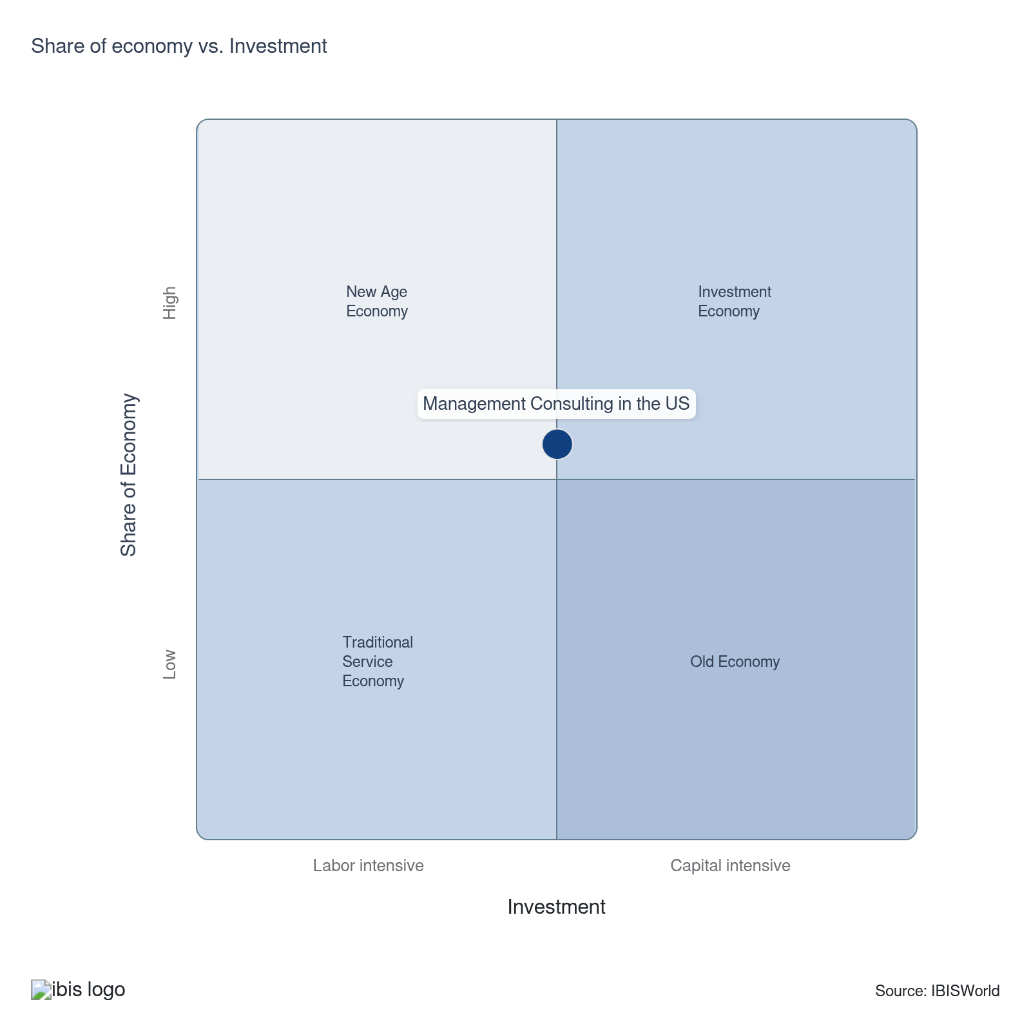

Financial Ratios

Earnings Ratios
Ratio | 2020 | 2021 | 2022 | 2023 | 2024 | 3-Year | 5-Year | 10-Year
EBIT/Revenue | 17.3 | 20.9 | 23.3 | 13.8 | 13.7 | 13.7 | 17.9 | 18.3
EBITDA/Revenue | 22.0 | 25.1 | 28.9 | 22.4 | 22.7 | 22.6 | 24.8 | 24.1
Leverage Ratio | 4.5 | 4.0 | 3.5 | 4.5 | 4.4 | 4.4 | 4.1 | 4.9

Industry Tax Structure
Ratio | 2020 | 2021 | 2022 | 2023 | 2024 | 3-Year | 5-Year | 10-Year
Taxes Paid/Revenue | 6.5 | 6.0 | 7.6 | 5.1 | 4.1 | 4.6 | 5.7 | 5.8

Income Statement
Ratio | 2020 | 2021 | 2022 | 2023 | 2024 | 3-Year | 5-Year | 10-Year
Total Revenue | 100.0 | 100.0 | 100.0 | 100.0 | 100.0 | 100.0 | 100.0 | 100.0
Business receipts | 91.7 | 93.4 | 94.6 | 79.1 | 97.5 | 88.3 | 91.1 | 92.7
Cost of goods | 34.3 | 29.9 | 31.0 | 33.8 | 26.7 | 30.2 | 30.3 | 29.6
Gross Profit | 65.7 | 70.1 | 69.0 | 66.2 | 73.3 | 69.8 | 69.7 | 70.4
Expenses
Salaries and wages | 15.4 | 14.5 | 11.7 | 15.4 | 12.8 | 14.1 | 13.6 | 15.2
Advertising | 4.4 | 4.3 | 4.3 | 3.2 | 2.6 | 2.9 | 3.6 | 4.1
Depreciation | 2.2 | 1.5 | 3.1 | 3.7 | 3.4 | 3.6 | 2.9 | 2.5
Depletion | 0.0 | 0.1 | 0.0 | 0.5 | 2.7 | 1.6 | 0.8 | 0.4
Amortization | 2.5 | 2.6 | 2.5 | 4.5 | 2.9 | 3.7 | 3.1 | 3.0
Rent paid | 3.1 | 2.9 | 1.9 | 2.8 | 2.1 | 2.4 | 2.4 | 3.0
Repairs | 0.4 | 2.0 | 0.4 | 3.1 | 1.3 | 2.2 | 1.7 | 1.0
Bad debts | 2.1 | 2.5 | 2.5 | 1.3 | 0.5 | 0.9 | 1.7 | 2.3
Employee benefit programs | 2.1 | 1.7 | 1.2 | 0.9 | 3.2 | 2.0 | 1.7 | 2.1
Compensation of officers | 1.8 | 1.3 | 1.4 | 0.9 | 9.2 | 5.1 | 3.2 | 2.2
Taxes paid | 6.5 | 6.0 | 7.6 | 5.1 | 4.1 | 4.6 | 5.7 | 5.8
Interest Income | 1.0 | 1.1 | 1.0 | 7.3 | 1.2 | 4.2 | 2.6 | 1.9
Other Income
Royalties | 4.1 | 0.2 | 0.7 | 2.0 | 0.6 | 1.3 | 0.9 | 1.0
Rent Income | 0.2 | 0.6 | 0.0 | 2.6 | 0.1 | 1.3 | 0.8 | 0.4
Net Income | 6.3 | 10.6 | 10.2 | -0.9 | 4.7 | 1.9 | 6.2 | 7.0
Charitable contributions | 0.1 | 0.0 | 0.0 | 0.0 | 0.0 | 0.0 | 0.0 | 0.0
Dividends | 0.2 | 0.2 | 0.3 | 0.2 | 0.0 | 0.1 | 0.2 | 0.2
Interest paid | 4.5 | 4.3 | 5.5 | 9.5 | 4.8 | 7.2 | 6.1 | 5.4
Net gain, noncapital assets | 0.0 | 1.6 | 0.2 | 0.2 | 0.0 | 0.1 | 0.5 | 0.3
Net long-term capital gain less net short-term loss | 0.2 | 0.2 | 0.8 | 4.5 | 0.4 | 2.5 | 1.5 | 0.8
Net loss, noncapital assets | 1.1 | 1.5 | 3.1 | 1.6 | 1.8 | 1.7 | 2.0 | 1.3
Net short-term capital gain less net long-term loss | 0.6 | 0.8 | 0.5 | 2.0 | 0.1 | 1.0 | 0.8 | 0.9
Other deductions | 12.9 | 14.2 | 13.4 | 14.5 | 15.0 | 14.8 | 14.3 | 14.4
Other receipts | 1.9 | 1.9 | 1.9 | 2.2 | 0.2 | 1.2 | 1.6 | 1.8
Pension, profit-sharing, etc., plans | 0.4 | 0.1 | 0.2 | 0.3 | 2.0 | 1.2 | 0.7 | 0.6

Balance Sheet
Ratio | 2020 | 2021 | 2022 | 2023 | 2024 | 3-Year | 5-Year | 10-Year
Assets
Cash and Equivalents | 16.1 | 10.4 | 13.0 | 9.6 | 8.6 | 9.1 | 10.4 | 12.5
Notes and accounts receivable | 10.4 | 14.9 | 17.0 | 15.9 | 16.5 | 16.2 | 16.1 | 11.2
Allowance for bad debts | 0.2 | 0.1 | 0.4 | 0.6 | 0.8 | 0.7 | 0.5 | 0.3
Inventories | 2.2 | 1.2 | 1.3 | 6.5 | 7.9 | 7.2 | 4.2 | 4.2
Other current assets | 6.6 | 6.3 | 8.2 | 7.2 | 7.9 | 7.6 | 7.4 | 5.8
Other investments | 21.6 | 23.0 | 17.3 | 16.1 | 16.9 | 16.5 | 18.3 | 22.8
Property, Plant and Equipment | 30.7 | 11.1 | 11.3 | 23.4 | 15.4 | 19.4 | 15.3 | 18.5
Accumulated depreciation | 14.4 | 2.2 | 6.4 | 15.8 | 8.6 | 12.2 | 8.3 | 7.9
Intangible assets (Amortizable) | 14.0 | 18.4 | 22.4 | 20.4 | 20.6 | 20.5 | 20.4 | 18.3
Accumulated amortization | 3.9 | 2.9 | 2.0 | 5.4 | 5.0 | 5.2 | 3.8 | 3.4
Other assets | 13.1 | 15.5 | 12.9 | 6.6 | 7.4 | 7.0 | 10.6 | 11.8
Total assets | 100.0 | 100.0 | 100.0 | 100.0 | 100.0 | 100.0 | 100.0 | 100.0
Accounts payable | 3.7 | 10.2 | 6.2 | 9.4 | 9.6 | 9.5 | 8.9 | 7.1
Liabilities and Net Worth
Mort, notes, and bonds under 1 yr | 4.5 | 2.7 | 2.7 | 7.4 | 7.4 | 7.4 | 5.0 | 4.7
Other current liabilities | 14.3 | 13.1 | 21.4 | 17.2 | 16.7 | 17.0 | 17.1 | 16.5
Loans from shareholders | 4.0 | 2.5 | 2.3 | 4.8 | 4.0 | 4.4 | 3.4 | 4.4
Mort, notes, bonds, 1 yr or more | 29.0 | 36.2 | 24.5 | 25.3 | 24.3 | 24.8 | 27.6 | 29.7
Other liabilities | 17.2 | 4.4 | 16.4 | 10.8 | 11.6 | 11.2 | 10.8 | 11.2
Total liabilities | 100.0 | 100.0 | 100.0 | 100.0 | 100.0 | 100.0 | 100.0 | 100.0
Capital stock | 16.0 | 14.9 | 15.8 | 9.7 | 6.6 | 8.2 | 11.8 | 10.2
Additional paid-in capital | 15.2 | 27.8 | 43.7 | 28.6 | 25.4 | 27.0 | 31.4 | 31.5
Retained earnings, appropriated | -4.0 | -4.3 | 1.4 | -6.6 | -3.7 | -5.1 | -3.3 | -5.3
Retained earnings-unappropriated | 23.8 | 16.4 | 2.8 | 12.2 | 13.6 | 12.9 | 11.3 | 13.9
Cost of treasury stock | 23.6 | 23.9 | 37.4 | 18.8 | 15.9 | 17.3 | 24.0 | 23.8
Net worth | 27.4 | 31.0 | 26.4 | 25.1 | 26.1 | 25.6 | 27.2 | 26.5
Accumulated depletion | 2.6 | 0.0 | 0.5 | 1.0 | 0.9 | 1.0 | 0.6 | 0.6
Depletable assets | 3.5 | 0.0 | 1.2 | 4.0 | 3.4 | 3.7 | 2.2 | 2.1
Government Obligations | 0.2 | 0.0 | 0.2 | 1.5 | 1.5 | 1.5 | 0.8 | 0.4
Land | 1.4 | 3.4 | 3.1 | 4.2 | 2.9 | 3.5 | 3.4 | 2.2
Loans to shareholders | 1.0 | 0.7 | 1.0 | 1.2 | 1.0 | 1.1 | 1.0 | 0.9
Mortgage and real estate loans | 0.2 | 0.2 | 0.2 | 4.7 | 4.3 | 4.5 | 2.3 | 1.1
Tax Exempt Securities | 0.0 | 0.0 | 0.0 | 1.4 | 1.2 | 1.3 | 0.7 | 0.3

Liquidity Ratios
Ratio | 2020 | 2021 | 2022 | 2023 | 2024 | 3-Year | 5-Year | 10-Year
Current Ratio | 1.6 | 1.3 | 1.3 | 1.3 | 1.3 | 1.3 | 1.3 | 1.2
Quick Ratio | 1.5 | 1.2 | 1.3 | 1.1 | 1.1 | 1.1 | 1.2 | 1.1
Sales/Receivables | 9.6 | 6.7 | 5.9 | 6.3 | 6.1 | 6.2 | 6.2 | 12.2
Days' Receivables | 38.0 | 54.4 | 62.0 | 58.2 | 60.2 | 59.2 | 58.7 | 40.9
Days' Inventory | 23.5 | 15.0 | 15.2 | 70.1 | 108.2 | 89.2 | 52.1 | 64.1
Inventory Turnover | 15.5 | 24.3 | 24.0 | 5.2 | 3.4 | 4.3 | 14.2 | 10.5
Payables Turnover | 9.2 | 2.9 | 5.0 | 3.6 | 2.8 | 3.2 | 3.6 | 5.5
Days' Payables | 39.5 | 124.8 | 73.2 | 101.7 | 132.0 | 116.8 | 107.9 | 103.9
Sales/Working Capital | 6.9 | 13.2 | 9.6 | 9.0 | 9.2 | 9.1 | 10.2 | 39.8

Coverage Ratios
Ratio | 2020 | 2021 | 2022 | 2023 | 2024 | 3-Year | 5-Year | 10-Year
Interest Coverage | 3.8 | 4.8 | 4.2 | 1.4 | 2.8 | 2.1 | 3.3 | 3.6
Debt Service Coverage Ratio | 0.7 | 6.6 | 4.7 | 2.7 | 2.7 | 2.7 | 4.2 | 2.4

Leverage Ratios
Ratio | 2020 | 2021 | 2022 | 2023 | 2024 | 3-Year | 5-Year | 10-Year
Fixed Assets/Net Worth | 2.6 | 1.2 | 1.8 | 3.0 | 2.2 | 2.6 | 2.0 | 2.0
Debt/Net Worth | 3.6 | 3.2 | 3.8 | 4.0 | 3.8 | 3.9 | 3.7 | 3.8
Tangible Net Worth | 27.4 | 31.0 | 26.4 | 25.1 | 26.1 | 25.6 | 27.2 | 26.5

Operating Ratios
Ratio | 2020 | 2021 | 2022 | 2023 | 2024 | 3-Year | 5-Year | 10-Year
Return on Net Worth, % | 63.2 | 67.6 | 88.4 | 54.9 | 52.4 | 53.7 | 65.8 | 60.1
Return on Assets, % | 17.3 | 20.9 | 23.3 | 13.8 | 13.7 | 13.7 | 17.9 | 18.3
Sales/Total Assets | 1.0 | 1.0 | 1.0 | 1.0 | 1.0 | 1.0 | 1.0 | 1.0
EBITDA/Revenue | 22.0 | 25.1 | 28.9 | 22.4 | 22.7 | 22.6 | 24.8 | 24.1
EBIT/Revenue | 17.3 | 20.9 | 23.3 | 13.8 | 13.7 | 13.7 | 17.9 | 18.3

Cash Flow & Debt Service Ratios (% of sales)
Ratio | 2020 | 2021 | 2022 | 2023 | 2024 | 3-Year | 5-Year | 10-Year
Cash from Trading | 70.6 | 69.1 | 75.0 | 56.8 | 72.2 | 64.5 | 68.3 | 71.3
Cash after Operations | 32.4 | 43.1 | 61.7 | 28.3 | 42.9 | 35.6 | 44.0 | 46.4
Net Cash after Operations | 41.7 | 41.6 | 50.3 | 29.6 | 43.0 | 36.3 | 41.1 | 43.5
Debt Service P&I Coverage | 3.5 | 4.2 | 5.0 | 1.5 | 3.0 | 2.2 | 3.4 | 3.3
Interest Coverage (Operating Cash) | 9.2 | 9.6 | 9.1 | 3.1 | 8.9 | 6.0 | 7.7 | 8.5

Valuation Multiples

Valuation Multiples
Ratio | 2020 | 2021 | 2022 | 2023 | 2024 | 3-Year | 5-Year | 10-Year
EV/Revenue | 0.3 | 0.5 | 0.4 | 0.5 | 0.5 | 0.5 | 0.5 | 0.5
EV/EBITDA | 0.6 | 0.8 | 0.7 | 1.2 | 1.0 | 1.0 | 0.9 | 0.9
EV/EBIT | 0.7 | 1.0 | 0.9 | 1.9 | 1.4 | 1.4 | 1.2 | 1.1

Key Ratios
Year | Revenue per Employee  ($) | Revenue per Enterprise  ($ Million) | Employees per Estab.  (Units) | Employees per Enterprise  (Units) | Average Wage  ($) | Wages/ Revenue  (%) | Estab. per Enterprise  (Units) | IVA/ Revenue  (%)
2005 | 163,930 | 0.4 | 2.6 | 2.6 | 84,653 | 51.6 | 1.0 | 63.2
2006 | 161,706 | 0.4 | 2.7 | 2.7 | 86,114 | 53.3 | 1.0 | 64.0
2007 | 159,383 | 0.4 | 2.2 | 2.3 | 83,747 | 52.5 | 1.0 | 63.5
2008 | 197,845 | 0.4 | 2.2 | 2.2 | 80,728 | 40.8 | 1.0 | 51.4
2009 | 182,567 | 0.4 | 2.0 | 2.0 | 75,414 | 41.3 | 1.0 | 51.8
2010 | 198,137 | 0.4 | 2.0 | 2.0 | 77,202 | 39.0 | 1.0 | 51.2
2011 | 200,576 | 0.4 | 2.0 | 2.0 | 77,050 | 38.4 | 1.0 | 50.6
2012 | 202,561 | 0.4 | 2.2 | 2.2 | 81,315 | 40.1 | 1.0 | 52.8
2013 | 203,144 | 0.5 | 2.2 | 2.2 | 79,548 | 39.2 | 1.0 | 49.5
2014 | 200,357 | 0.5 | 2.2 | 2.3 | 78,328 | 39.1 | 1.0 | 49.9
2015 | 199,384 | 0.5 | 2.3 | 2.3 | 80,548 | 40.4 | 1.0 | 51.4
2016 | 199,492 | 0.5 | 2.3 | 2.3 | 81,578 | 40.9 | 1.0 | 46.0
2017 | 195,136 | 0.4 | 2.3 | 2.3 | 82,822 | 42.4 | 1.0 | 47.5
2018 | 189,160 | 0.4 | 2.3 | 2.3 | 83,347 | 44.1 | 1.0 | 55.4
2019 | 188,956 | 0.4 | 2.3 | 2.3 | 84,825 | 44.9 | 1.0 | 56.7
2020 | 178,556 | 0.4 | 2.2 | 2.2 | 83,155 | 46.6 | 1.0 | 58.3
2021 | 186,742 | 0.4 | 2.2 | 2.2 | 87,061 | 46.6 | 1.0 | 59.6
2022 | 180,260 | 0.4 | 2.3 | 2.3 | 85,525 | 47.4 | 1.0 | 60.1
2023 | 172,650 | 0.4 | 2.3 | 2.3 | 84,146 | 48.7 | 1.0 | 61.1
2024 | 170,812 | 0.4 | 2.3 | 2.3 | 83,969 | 49.2 | 1.0 | 61.4
2025 | 168,905 | 0.4 | 2.2 | 2.3 | 83,782 | 49.6 | 1.0 | 61.8
2026 | 166,682 | 0.4 | 2.2 | 2.2 | 83,559 | 50.1 | 1.0 | 62.2
2027 | 164,555 | 0.4 | 2.2 | 2.2 | 83,346 | 50.6 | 1.0 | 62.6
2028 | 163,048 | 0.4 | 2.2 | 2.2 | 83,193 | 51.0 | 1.0 | 62.9
2029 | 161,623 | 0.3 | 2.1 | 2.2 | 83,048 | 51.4 | 1.0 | 63.1
2030 | 160,327 | 0.3 | 2.1 | 2.1 | 82,915 | 51.7 | 1.0 | 63.4
2031 | 159,495 | 0.3 | 2.1 | 2.1 | 82,828 | 51.9 | 1.0 | 63.6
2032 | 158,728 | 0.3 | 2.1 | 2.1 | 82,749 | 52.1 | 1.0 | 63.7
*Figures are inflation adjusted to 2026
*Figures are inflation adjusted to 2026

10. Key Statistics
https://my.ibisworld.com/us/en/industry/54161/key-statistics

Industry Data

Values
Year | Revenue  ($ Million) | IVA  ($ Million) | Estab.  (Units) | Enterprises  (Units) | Employment  (Units) | Wages  ($ Million)
2005 | 190,286.2 | 120,313.4 | 454,596 | 448,575 | 1,160,777 | 98,263.2
2006 | 193,609.2 | 123,820.6 | 442,545 | 436,013 | 1,197,294 | 103,103.7
2007 | 204,734.8 | 129,965.6 | 571,479 | 564,758 | 1,284,550 | 107,577.6
2008 | 220,004.6 | 113,157.4 | 516,917 | 512,128 | 1,112,002 | 89,770.1
2009 | 216,337.0 | 112,168.9 | 605,354 | 600,090 | 1,184,971 | 89,363.2
2010 | 237,700.5 | 121,714.5 | 600,871 | 595,530 | 1,199,680 | 92,618.2
2011 | 251,934.3 | 127,356.7 | 619,422 | 613,165 | 1,256,055 | 96,778.6
2012 | 272,044.2 | 143,643.4 | 622,447 | 616,119 | 1,343,025 | 109,208.4
2013 | 282,542.4 | 139,861.2 | 633,719 | 625,924 | 1,390,849 | 110,638.6
2014 | 295,648.3 | 147,572.9 | 656,639 | 648,800 | 1,475,609 | 115,580.9
2015 | 300,107.1 | 154,330.3 | 662,745 | 655,280 | 1,505,172 | 121,238.1
2016 | 314,550.7 | 144,637.2 | 699,182 | 691,383 | 1,576,760 | 128,628.7
2017 | 317,538.5 | 150,892.6 | 718,879 | 711,147 | 1,627,269 | 134,773.2
2018 | 324,385.3 | 179,558.4 | 753,256 | 745,118 | 1,714,870 | 142,928.7
2019 | 336,790.3 | 190,970.8 | 788,427 | 780,139 | 1,782,376 | 151,190.9
2020 | 343,773.9 | 200,251.0 | 874,508 | 866,248 | 1,925,299 | 160,098.1
2021 | 370,812.5 | 221,055.1 | 913,725 | 905,622 | 1,985,693 | 172,876.4
2022 | 381,175.2 | 228,931.9 | 924,984 | 916,998 | 2,114,591 | 180,850.5
2023 | 393,120.6 | 240,003.2 | 998,154 | 989,137 | 2,276,979 | 191,599.1
2024 | 400,663.0 | 245,980.7 | 1,037,299 | 1,028,605 | 2,345,634 | 196,960.4
2025 | 407,874.1 | 251,878.4 | 1,078,477 | 1,070,202 | 2,414,817 | 202,317.9
2026 | 411,684.8 | 255,914.3 | 1,116,823 | 1,109,213 | 2,469,881 | 206,381.0
2027 | 415,193.5 | 259,731.2 | 1,155,085 | 1,148,197 | 2,523,125 | 210,292.0
2028 | 419,679.5 | 263,784.0 | 1,188,294 | 1,181,925 | 2,573,964 | 214,136.2
2029 | 424,004.4 | 267,640.3 | 1,220,582 | 1,214,734 | 2,623,420 | 217,869.1
2030 | 427,976.7 | 271,298.4 | 1,254,843 | 1,249,623 | 2,669,396 | 221,331.9
2031 | 432,405.7 | 274,862.5 | 1,285,068 | 1,280,340 | 2,711,101 | 224,556.3
2032 | 436,506.9 | 278,171.0 | 1,313,911 | 1,309,675 | 2,750,037 | 227,562.3

*Figures are inflation adjusted to 2026

Annual Change
Year | Revenue  % | IVA  % | Estab.  % | Enterprises  % | Employment  % | Wages  %
2005 | N/A | N/A | N/A | N/A | N/A | N/A
2006 | 1.7 | 2.9 | -2.7 | -2.8 | 3.1 | 4.9
2007 | 5.7 | 5.0 | 29.1 | 29.5 | 7.3 | 4.3
2008 | 7.5 | -12.9 | -9.5 | -9.3 | -13.4 | -16.6
2009 | -1.7 | -0.9 | 17.1 | 17.2 | 6.6 | -0.5
2010 | 9.9 | 8.5 | -0.7 | -0.8 | 1.2 | 3.6
2011 | 6.0 | 4.6 | 3.1 | 3.0 | 4.7 | 4.5
2012 | 8.0 | 12.8 | 0.5 | 0.5 | 6.9 | 12.8
2013 | 3.9 | -2.6 | 1.8 | 1.6 | 3.6 | 1.3
2014 | 4.6 | 5.5 | 3.6 | 3.7 | 6.1 | 4.5
2015 | 1.5 | 4.6 | 0.9 | 1.0 | 2.0 | 4.9
2016 | 4.8 | -6.3 | 5.5 | 5.5 | 4.8 | 6.1
2017 | 0.9 | 4.3 | 2.8 | 2.9 | 3.2 | 4.8
2018 | 2.2 | 19.0 | 4.8 | 4.8 | 5.4 | 6.1
2019 | 3.8 | 6.4 | 4.7 | 4.7 | 3.9 | 5.8
2020 | 2.1 | 4.9 | 10.9 | 11.0 | 8.0 | 5.9
2021 | 7.9 | 10.4 | 4.5 | 4.5 | 3.1 | 8.0
2022 | 2.8 | 3.6 | 1.2 | 1.3 | 6.5 | 4.6
2023 | 3.1 | 4.8 | 7.9 | 7.9 | 7.7 | 5.9
2024 | 1.9 | 2.5 | 3.9 | 4.0 | 3.0 | 2.8
2025 | 1.8 | 2.4 | 4.0 | 4.0 | 2.9 | 2.7
2026 | 0.9 | 1.6 | 3.6 | 3.6 | 2.3 | 2.0
2027 | 0.9 | 1.5 | 3.4 | 3.5 | 2.2 | 1.9
2028 | 1.1 | 1.6 | 2.9 | 2.9 | 2.0 | 1.8
2029 | 1.0 | 1.5 | 2.7 | 2.8 | 1.9 | 1.7
2030 | 0.9 | 1.4 | 2.8 | 2.9 | 1.8 | 1.6
2031 | 1.0 | 1.3 | 2.4 | 2.5 | 1.6 | 1.5
2032 | 0.9 | 1.2 | 2.2 | 2.3 | 1.4 | 1.3

*Figures are inflation adjusted to 2026

DISCLAIMER
This product has been supplied by IBISWorld Inc. (‘IBISWorld’) solely for use by its authorized licenses strictly in accordance with their license agreements with IBISWorld. IBISWorld makes no representation to any other person with regard to the completeness or accuracy of the data or information contained herein, and it accepts no responsibility and disclaims all liability (save for liability which cannot be lawfully disclaimed) for loss or damage whatsoever suffered or incurred by any other person resulting from the use of, or reliance upon, the data or information contained herein. Copyright in this publication is owned by IBISWorld Inc. The publication is sold on the basis that the purchaser agrees not to copy the material contained within it for other than the purchasers own purposes. In the event that the purchaser uses or quotes from the material in this publication – in papers, reports, or opinions prepared for any other person – it is agreed that it will be sourced to: IBISWorld Inc.

